



Seventh Session of
SOUTHEASTERN EUROPE CLIMATE OUTLOOK FORUM (SEECOF-7)
April-May, 2012

SEASONAL OUTLOOK FOR SUMMER SEASON 2012 FOR THE SOUTH EASTERN EUROPE AND CAUCASUS REGION (SEE&C)
Climate experts from WMO RA VI RCC Network Nodes on long-range forecasting (Meteo France, France and Roshydromet, Russia) and WMO RA VI RCC Network Node on climate monitoring (Deutscher Wetterdienst, Germany), UK Met-Office, Global Producing Centre ECMWF, International Research Institute for Climate and Society (IRI, USA), National Centers for Environmental Prediction (NCEP,USA), South East Europe Virtual Climate Change Centre (SEEVCCC, Serbia) and National Hydrometeorological Services of SEECOF region provided their valuable contribution to the successful implementation of SEECOF-7 by developing the relevant documents and providing scientific guidance and recommendations.
The SEECOF-7 comprised of the following Steps:
- Step 1: qualitative verification of the SEECOF-6 climate outlook for 2011-2012 Winter;
- Step 2: assessment of the current state of the climate including large-scale climate patterns worldwide and assessments of its likely evolution in the course of the next months;
- Step 3: building the consensus forecast for 2012 Summer season.
All relevant documentation is posted and updated in SEEVCCC web site: http://www.seevccc.rs

SEECOF- 7 CLIMATE OUTLOOK
FOR 2012 SUMMER SEASON

This prediction is based on output from dynamical models, statistical models and known teleconnections of large-scale climate features. Since February 2012, positive anomalies of the Sea Surface Temperatures (SSTs) have developed and persisted in the Eastern Pacific, while negative anomalies have been weakening in the central Pacific. La Nina event dissipated during April. Since the beginning of May ENSO-neutral conditions have been established and are expected to continue during the summer season 2012. It can be noted that almost all dynamical models predict above normal, but still close to neutral ENSO-conditions (below an El Nino threshold). Below normal SST conditions are forecasted in the Eastern part of North Tropical Atlantic, close to West Africa, as well as over the South Tropical Atlantic. Over the most of the Tropical Indian Ocean SSTs will be close to normal conditions and it will be warmer than normal over the southern part of the basin, but the North-Western part should be faced with below normal conditions. Above SST normal conditions were observed over the Eastern Mediterranean Sea during the past few months. A persistence of this pattern is very likely to exist during the summer season 2012. As for the Arctic Oscillation/North Atlantic Oscillation, the ECMWF prediction system suggests the development of a small negative phase throughout June and July and a slightly positive one in August

The maps show the probabilistic consensus forecast for tercile categories of anomalies of seasonal-mean temperature and precipitation, relative to the period 1961-1990.
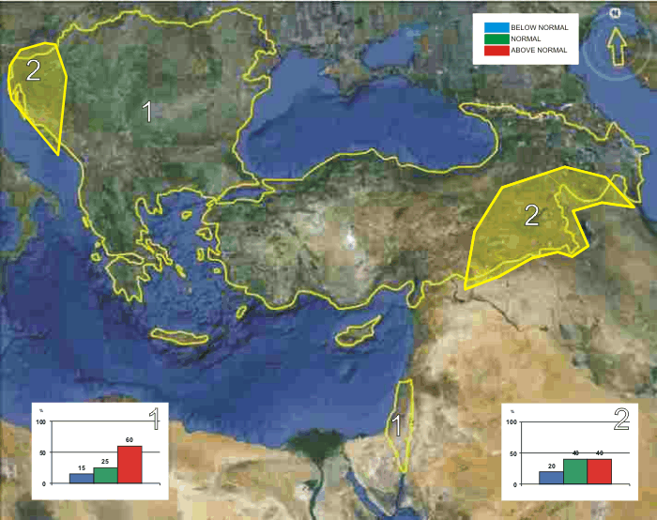
Figure 1. Graphical presentation 2012 summer temperature outlook
In summary, in the most of the SEECOF region (zone 1 in Figure 1) there is more likelihood for the above average summer season temperature, while in the western part of the Balkan Peninsula, eastern part of Turkey and southern parts of the Caucasus region (zone 2 in Figure 1), it is likely to be near- to above average.

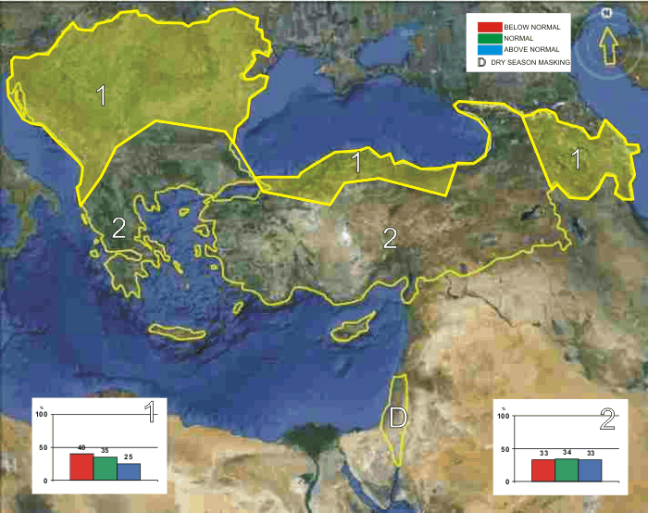
Figure 2. Graphical presentation 2012 summer precipitation outlook

Uncertainties, in regional predictions are larger for precipitation than for temperature. In the Pannonia Plain, most of the Balkan Peninsula, along the southern and western banks of the Black Sea and in the eastern part of the Caucasus region summer season precipitation totals is likely to be near- or below-average conditions (zone 1 in Figure 2). In the rest of the SEECOF region (zone 2 in Figure 2) the uncertainty is large: probabilities for below-, near- or above-average conditions are approximately equal. It must be emphasized that it might be possible that some parts, especially mountainous ones, might locally have above normal summer season totals, due to episodes of the enhanced convection with high intensity rainfall.

Any further advice on the forecast signals, shorter-range updates and warnings will be available throughout the summer from the National Meteorological Services, along with details on the methodology and skill of long-range predictions.

CLIMATE OUTLOOK FOR SUMMER 2012 IN SERBIA

It is expected that mean summer air temperature in entire Serbia will be above multiannual average. It is forecasted that the number of tropical days with maximum temperature of above 30 ̊ С during June, July and August will amount from 34 to 49, while it will reach 5 days in hilly and mountainous parts. The number of tropical nights with minimum temperature of above 20 ̊ С will range from 4 to 8 in most part of Serbia, with the exception of hilly and mountainous parts, while in Belgrade there will be about 20 tropical nights this summer.

In most part of Serbia, summer precipitation quantity will be around or below average. An exception might be certain parts of mountainous areas, where precipitation might be more intense due to increased convection.

Thus, the summer of 2012 in entire Serbia will be warmer than average, with precipitation around and somewhat below normal.

* The graphical representation of climate outlook in this statement is only for guidance purposes, and does not imply any opinion whatsoever concerning the legal status of any country, territory, city or area or of its authorities, or concerning the delimitation of its frontiers or boundaries.

