



Eleventh Session of
SOUTHEASTERN EUROPE CLIMATE OUTLOOK FORUM (SEECOF-11)
April-May, 2014

SEASONAL OUTLOOK FOR SUMMER SEASON 2014 FOR THE SOUTH EASTERN EUROPE AND CAUCASUS REGION (SEE&C)
Climate experts from WMO RA VI RCC Network Nodes on long-range forecasting (Meteo France, France and Roshydromet, Russia) and WMO RA VI RCC Network Node on climate monitoring (Deutscher Wetterdienst, Germany), UK Met-Office, Global Producing Centre ECMWF, International Research Institute for Climate and Society (IRI, USA), National Centers for Environmental Prediction (NCEP,USA), WMO RA VI RCC South East Europe Virtual Climate Change Centre (SEEVCCC, Serbia) and National Hydrometeorological Services of SEECOF region provided their valuable contribution to the successful implementation of SEECOF-11 by developing the relevant documents and providing scientific guidance and recommendations.
The SEECOF-11 comprised of the following Steps:
- Step 1: qualitative verification of the SEECOF-10 climate outlook for 2013-2014 Winter;
- Step 2: assessment of the current state of the climate including large-scale climate patterns worldwide and assessments of its likely evolution in the course of the next months;
- Step 3: building the consensus forecast for 2014 Summer season.
All relevant documentation is posted and updated in SEEVCCC web site: http://www.seevccc.rs

SEECOF-11 CLIMATE OUTLOOK
FOR THE 2013/14 SUMMER SEASON

As well as, the MedCOF-2 seasonal climate outlook, SEECOF-11 prediction is based on the output from dynamical models, including, inter alia, the operational products of the SEEVCCC centre, statistical models and known teleconnections of large-scale climate features.

The expected development of a warm event in the Pacific suggests some possible predictability, mostly located in the Tropics at this stage (Pacific, Indian Ocean and Atlantic). Nevertheless, certain predictability could be present over the Mediterranean basin.

The maps show the probabilistic consensus forecast for the tercile categories of anomalies for seasonal mean temperature and precipitation, relative to the period 1981-2010. Due to the climate warming trend anomalies are affected by the selected reference period.

In the almost whole SEECOF region there is likelihood for above-average temperature. There is less probability for exceeding the average temperature in most of the Pannonia plain, western, central and eastern parts of the Balkan Peninsula, Jordan and central parts of the Caucasus region (zone 2 in Figure 1), while there is higher probability for above-average conditions in other parts of the SEECOF region (zone 1 in Figure 1). In some parts of continental Turkey (zone 3 in Figure 1) the uncertainty is large: probabilities for below-, near- or above- average conditions are approximately equal.

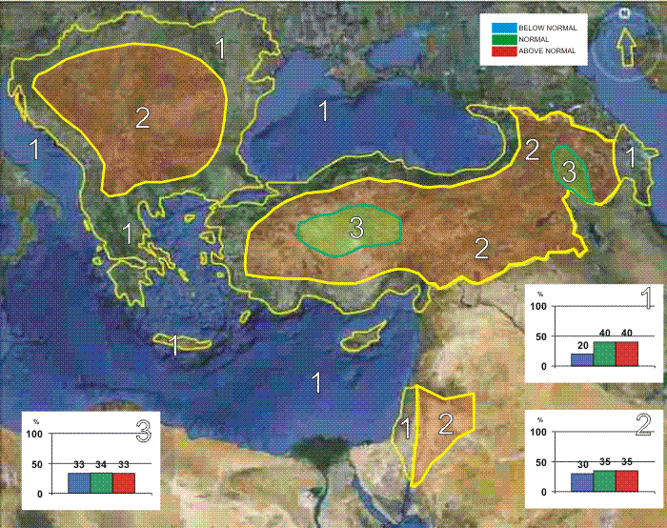
Figure 1. Graphical presentation of the 2014 summer temperature outlook

Uncertainties in regional predictions are larger for precipitation than for temperature. Along the coasts of the Caspian Sea summer season precipitation totals are likely to be near- or below- average (zone 2 in Figure 2). In the Pannonia plain, western, central and eastern part of the Balkan Peninsula, as well as in the continental part of the Caucasus region (zone 3 in Figure 2) the uncertainty is large: probabilities for below-, near- or above- average conditions are approximately equal. On the other hand, in the rest of the SEECOF region summer season totals are likely to be near- or above-average (zone 1 in Figure 2). It must be emphasized that it might be possible that some parts, especially mountainous ones, might locally have near- or above- normal summer season totals, due to episodes of the enhanced convection with high intensity rainfall. Along the southern coasts of the eastern Mediterranean, and in Israel and Jordan, it is not possible to forecast summer season precipitation due to dry season masking.

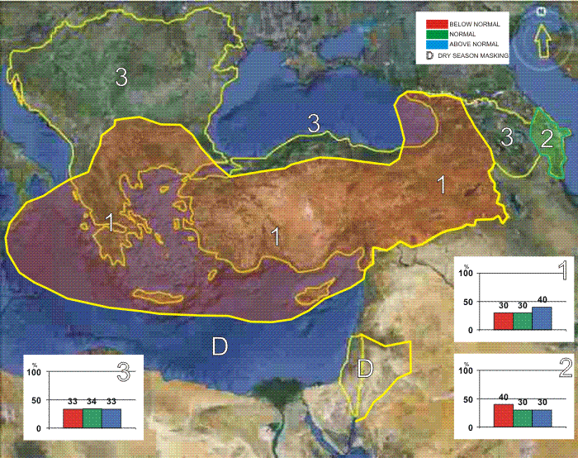
Figure 2. Graphical presentation of the 2014 summer precipitation outlook

Reference:
The maps show the probabilistic consensus forecast for tercile categories of anomalies of seasonal-mean temperature and precipitation, relative to the period 1981-2010.

Any further advice on the forecast signals, shorter-range updates and warnings will be available throughout the summer from the National Meteorological Services, along with the details on the methodology and skill of long-range predictions.

* The graphical representation of climate outlook in this statement is for guidance purposes only, and does not imply any opinion whatsoever concerning the legal status of any country, territory, city or area or of its authorities, or concerning the delimitation of its frontiers or boundaries.

APPENDIX A: Contributors to SEECOF-11

- World Meteorological Organization
- Met Office, United Kingdom
- International Research Institute for Climate and Society, United States of America
- European Center for Medium Range Weather Forecast
- Meteo France, Republic of France
- Deutscher Wetterdienst, Federal Republic of Germany
- National Center for Environmental Prediction, United States of America
- South East European Virtual Climate Change Center hosted by Republic Hydrometeorological Service of Serbia, Republic of Serbia
- Institute of Geosciences, Energy, Water and Environment, Albania
- Armenian State Hydrometeorological and Monitoring Service, Armenia
- National Institute of Meteorology and Hydrology, Republic of Bulgaria
- Meteorological and Hydrological Service, Republic of Croatia
- Meteorological Service, Republic of Cyprus
- Hellenic National Meteorological Service, Greece
- The National Environmental Agency of Georgia, Georgia
- Hungarian Meteorological Service, Hungary
- Israel Meteorological Service, State of Israel
- Republic Hydrometeorological Institute, Former Yugoslav Republic of Macedonia
- Hydrometeorological Institute of Montenegro, Montenegro
- National Meteorological Administration, Romania
- Federal Hydrometeorological Service of the Federation of Bosnia and Herzegovina, Federation of Bosnia and Herzegovina, Bosnia and Herzegovina
- Republic Hydrometeorological Service of the Republic of Srpska, Republic of Srpska, Bosnia and Herzegovina
- Republic Hydrometeorological Service of Serbia, Republic of Serbia
- Turkish State Meteorological Service, Republic of Turkey

