
REPUBLIC OF SERBIA
REPUBLIC HYDROMETEOROLOGICAL SERVICE

Republic Hydrometeorological Service and Federal Hydrometeorological Service of the Federation of Bosnia and Herzegovina have signed a"AGREEMENT ON THE SCIENTIFIC-TECHNICAL COOPERATION IN METEOROLOGY, CLIMATE CHANGES, HYDROLOGY AND AIR AND WATER QUALITY MONITORING”.

The Agreement was signed by the Mr. Milan Dacic, Director of Hydrometeorological Service of the Republic of Serbia and Permanent Representative with the World Meteorological Organization (WMO) and Mr Enes Sarač, Director of Federal Hydrometeorological Service of the Federation of Bosnia and Herzegovina and Permanent Representative with WMO, on 10 June 2009 in Sarajevo.

The Agreement was signed for the purpose of upgrading the cooperation of these institutions in scientific and technical fields of meteorology, climate changes, hydrology and air and water quality monitoring. On the basis of the Agreement, both signatories have the obligation to establish the cooperation in accordance with their needs and possibilities, honoring the principles of the WMO. The Agreement will contribute to the strengthening of common initiatives in bilateral and regional cooperation in the framework of international expert and scientific-research programs and projects of the World Meteorological Organization and other international organizations as well as the program of technical cooperation.
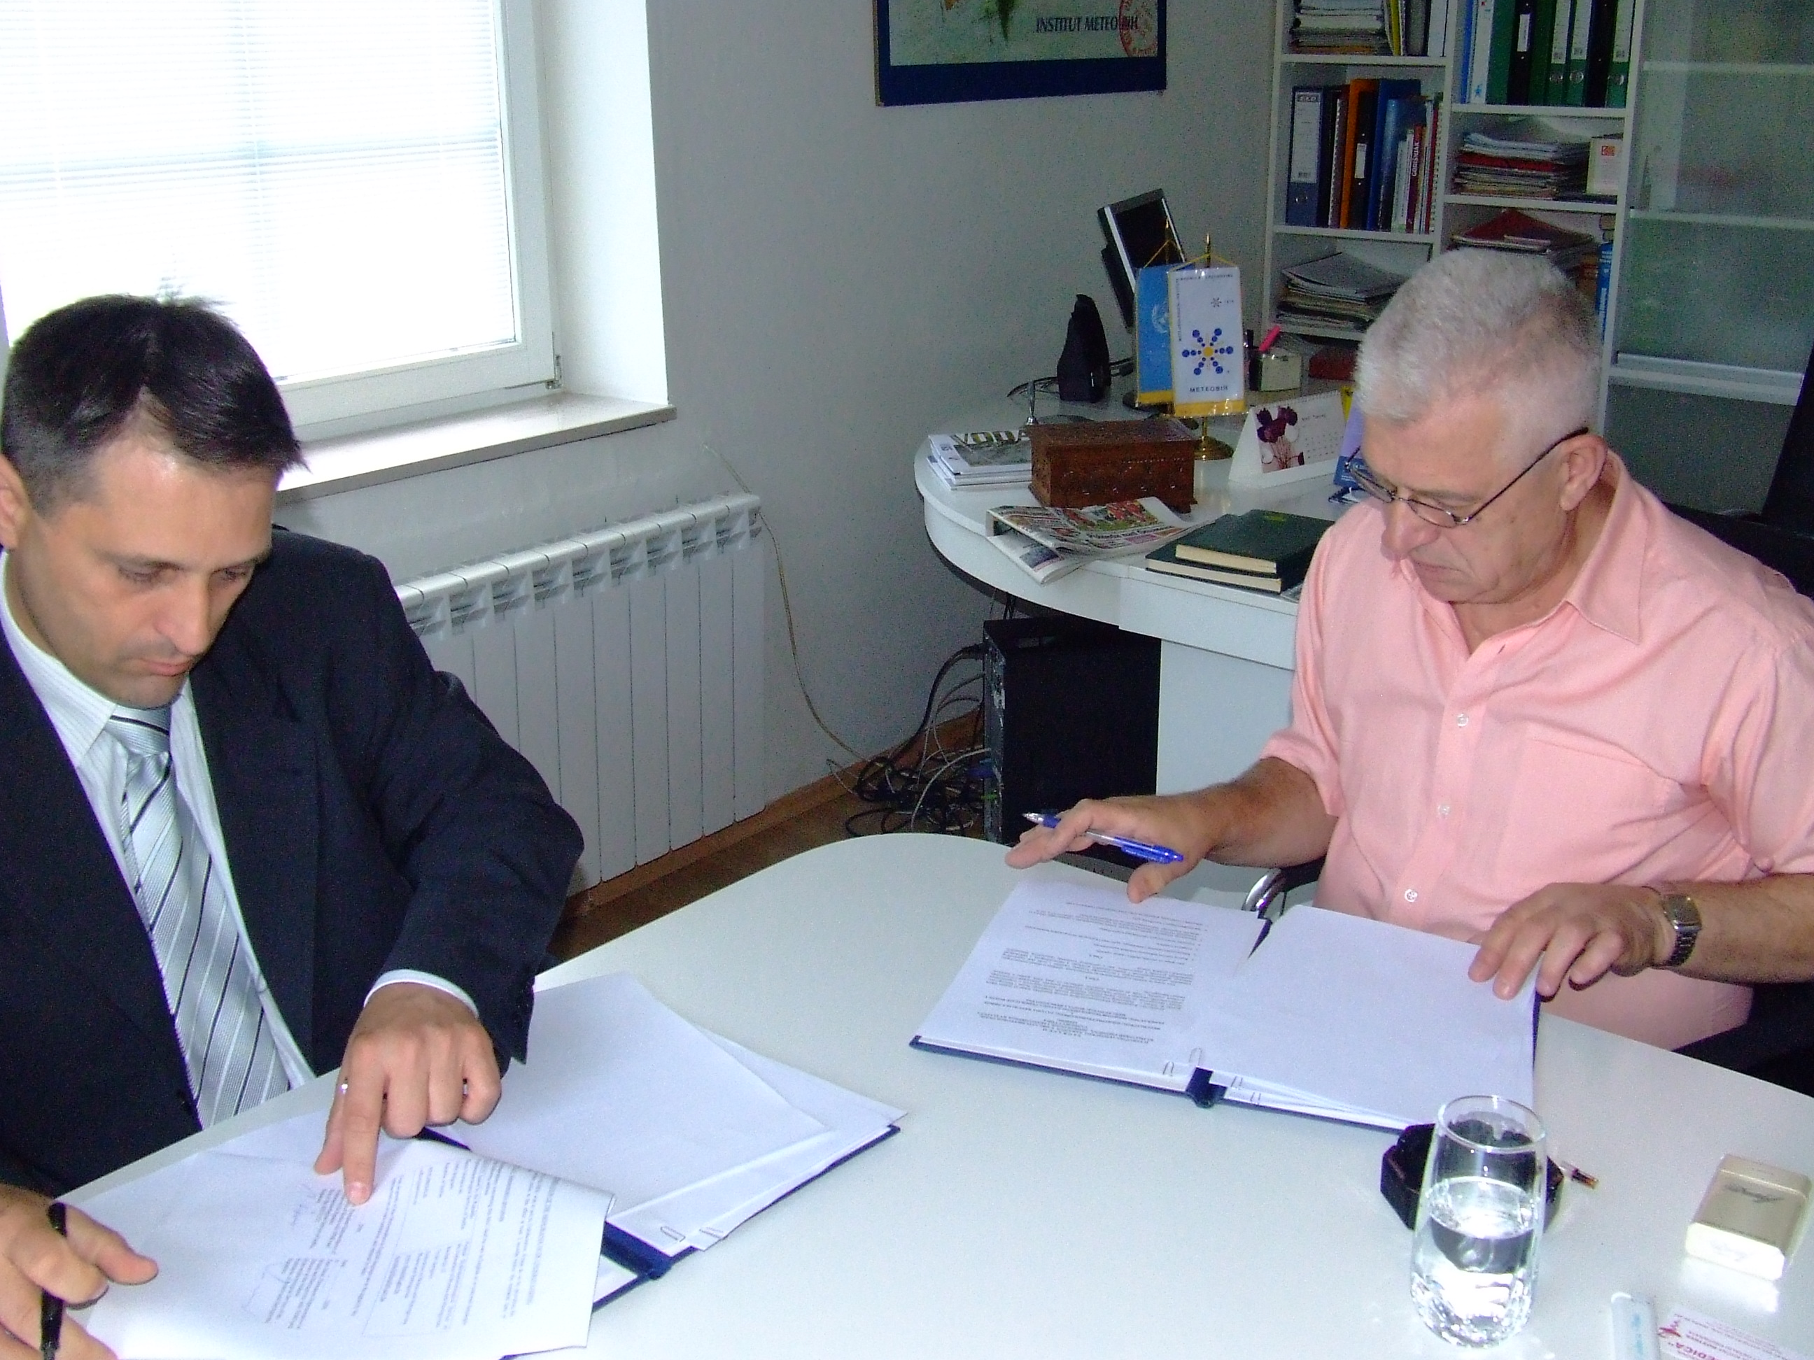
Signing of the Agreement on scientific-technical cooperation in the field of meteorology, climate changes, hydrology and air and water quality monitoring, by Mr Milan Dacic, Director of the RHMS of Serbia and Permanent Representative with WMO and Mr Enes Sarač, Director of the Federal Hydrometeorological Service and Permanent Representative with WMO, in Sarajevo, Bosnia and Herzegovina, on 10 June 2009.

Besides the Agreement, a ”Memorandum of Understanding” between the Virtual Climate Centre for South East Europe-SEEVCCC and Federal Hydrometeorological Service of the Federation of Bosnia and Herzegovina as well as the Hydrometeorological Service of Montenegro.
Signatories of this Memorandum expressed their wish to joint efforts that would lead to the strengthening of fruitful cooperaation and productive activities in the field of climate changes.
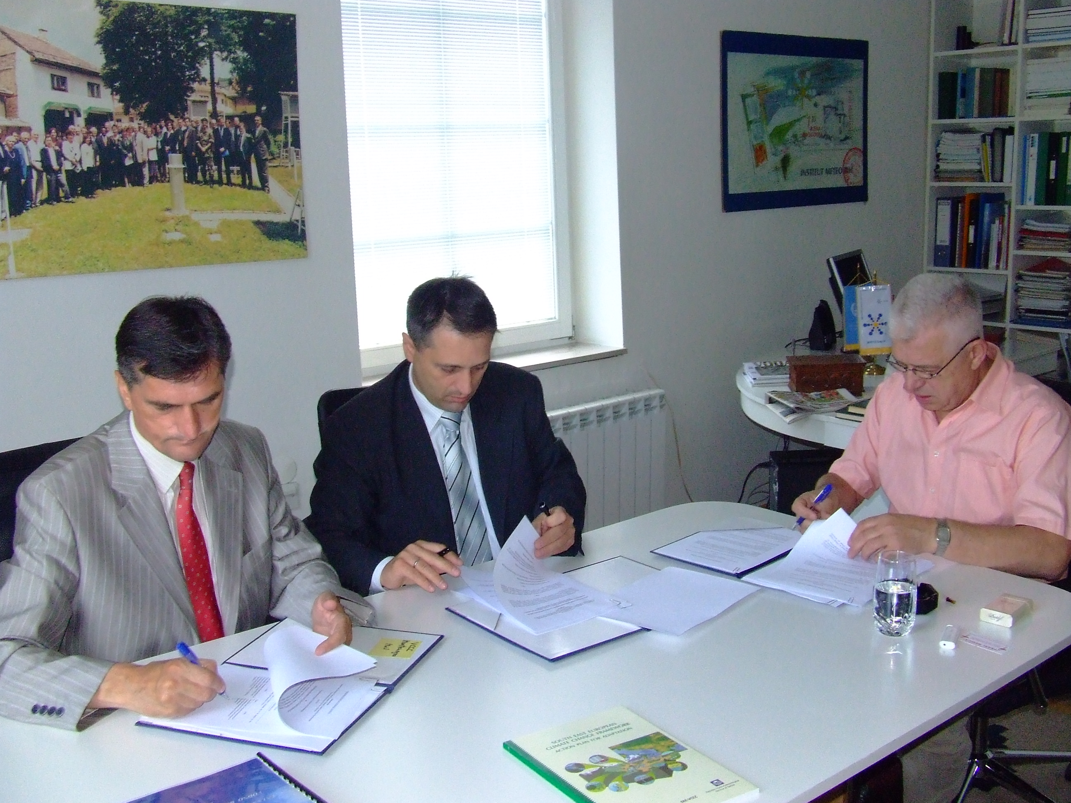
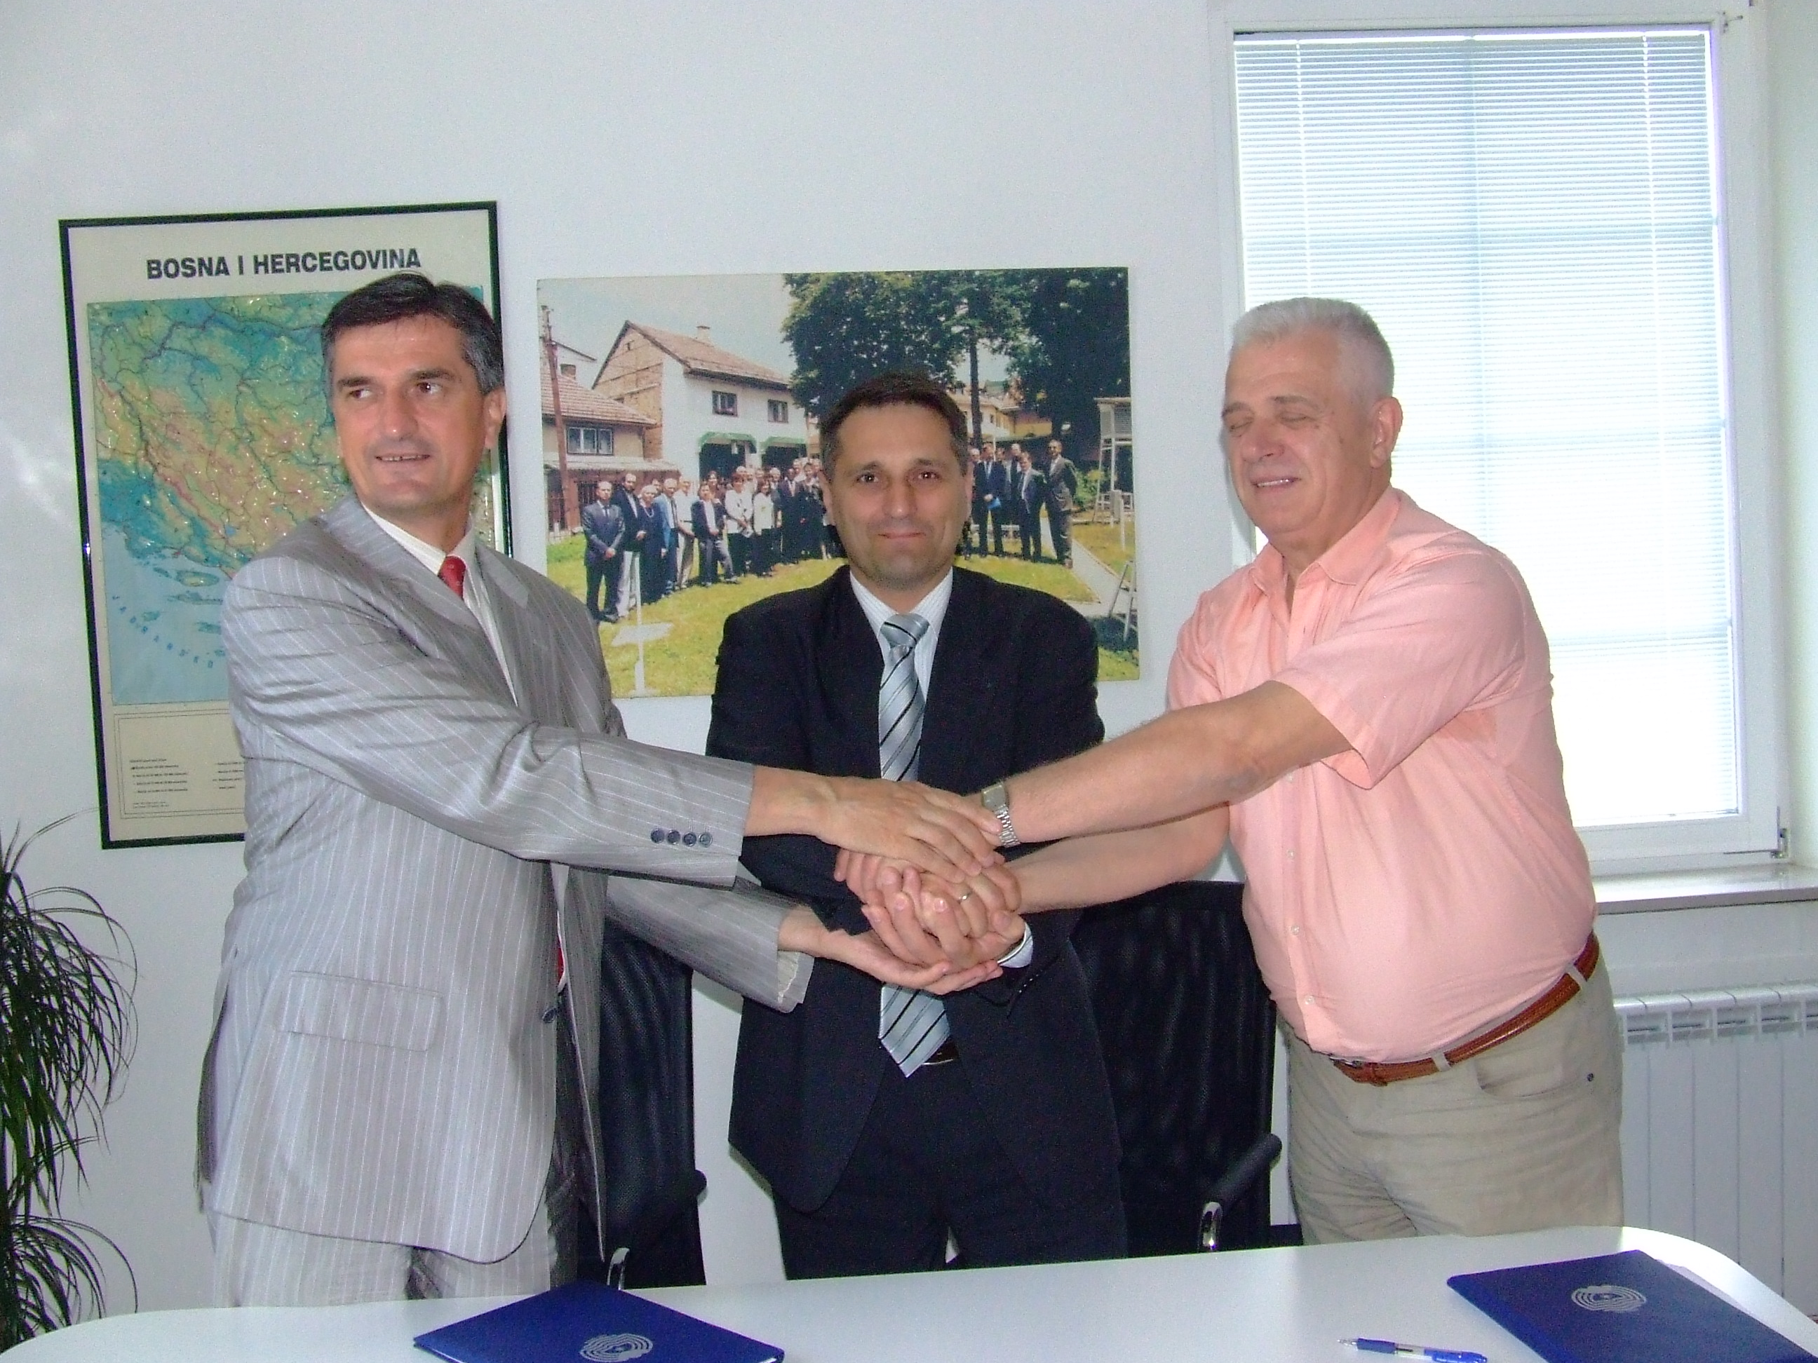
Awareness of the vulnerability of the countries in South East Europe (SEE) to the existing and, especially, potential future climate changes, in the field of agriculture and forestry, water resources, human health, energy, tourism and infrastructure, brought about the establishment of partner relations between the SEE countries in the capacity building, training, education and increasing the awareness of the public about the significance of climate changes. Common interest was also established for the improvement of climate monitoring and research, application of various methods for the assessment of the influence of climate changes, assessment of the vulnerability and adaptation as well as common participation in projects and programs of European Union and other bilateral and multilateral initiatives.

Signing of the “Memorandum on Cooperation” between the Virtual Climate Centre for South East Europe-SEEVCCC and Federal Hydrometeorological Service of the Federation of Bosnia and Herzegovina and also with the Hydrometeorological Service of Montenegro by Mr Luka Mitrovic, Director of Hydrometeorological Service of Montenegro and Permanent Representative with WMO, Mr Milan Dacic, Director of Hydrometeorological Service of Serbia and Permanent Representative with WMO and Mr Enes Sarač, Director of Federal Hydrometeorological Service of the Federation of Bosnia and Herzegovina and Permanent Representative with WMO,
in Sarajevo, Bosnia and Herzegovina, on 10 June 2009.

