Project report

for the project Hydrological Flood Forecasting System for Small and Medium Sized Catchments in Serbia, 2009 – 2010


Documentation and technical references

Ministry of Foreign Affairs, Norway
The Republic Hydrometeorological Service of Serbia (RHMSS)
The Norwegian Water Resources and Energy Directorate (NVE)

Norwegian Water Resources and Energy Directorate
2026
Report no. X – 201X
Project report

Published by: | Norwegian Water Resources and Energy Directorate
Editor:
Authors: | Elin Langsholt

Print: | Norwegian Water Resources and Energy Directorate
Number printed: | 10
Cover photo: | The confluence of Sava with Danube, Belgrade, May 2008, Photo by Elin Langsholt
ISSN:
ISBN:

Abstract: | The report gives a summary of the project Hydrological Flood Forecasting System for Small and Medium Sized Catchments in Serbia, a collaboration project between Republic Hydrometeorological Service of Serbia (RHMSS) and Norwegian Water and Energy Directorate (NVE), with financial support from the Norwegian Ministry of Foreign Affairs.
Key words: | Hydrological information system, WISKI, hydrological model, HBV-model, Serbia

Norwegian Water Resources and Energy Directorate
Middelthunsgate 29
P.O. Box 5091 Majorstua
N 0301 OSLO
NORWAY

Telephone: +47 22 95 95 95
Fax: +47 22 95 90 00
E-mail: nve@nve.no
Internet: www.nve.no

February 2011

Contents
Preface 5
Summary 6
1 About the project 7
2 The hydrological information management system 7
2.1 Acquirement and specification 7
2.2 WISKI 7 8
3 The hydrological model 9
3.1 Acquirement 9
3.2 HBV/IHMS 9
Conclusions 10
Acknowledgements 10
References 10
Appendix 1 11
Hydrological Flood Forecasting System for Small and Medium Sized Catchments in Serbia. Project proposal for the years 2009 & 2010NVE ref. 200710272-13 11
Appendix 2 34
Knut Møen, 2008. Status report on hydrological data management system. Annex 3 to Aide Memoire from Visit of NVE specialists to RHMSS 26 - 30 May, 2008, Belgrade. NVE ref. 200710272-7. 34
Appendix 3 38
NVE, 2009. Request for tender. 2009. NVE ref. 200710272-22. 38
Appendix 4 42
Contract between Kisters AG and Norwegian Water Resources and Energy Directorate. NVE ref. 200710272-29 42
Appendix 5 44
Status of Christmas update delivery and next steps. NVE ref. -200710272-33 44
Appendix 6 46
Declaration of acceptance. NVE ref. 200710272-53. 46
Appendix 7 48
SMHI, 2010. Proposal; Installation of HBV/IHMS 6.x software, manual integration with WISKI-database system, and training in the use of HBV/IHMS Hydrological Modelling Software. NVE ref. 200710272-23. 48
Appendix 8 52
NVE, 2009. Order of software, installation of software and training course. NVE ref. 200710272-24. 52
Appendix 9 53
HBV models for 10 Pilot catchments in Serbia. Calibration results. NVE ref. 200710272-63. 53
Appendix 10 54
SMHI, 2010. Proposal; Development of software modules to allow Automatic HBV-model simulations/forecasts and generation of pdf-document with forecast information at RHMSS, Serbia. NVE ref. 200710272-54. 54

Preface

NVE has been involved in several bilateral projects on Balkan, related to hydrology, water resource planning and station network design. As a continuation of this involvement, a pre-project was initiated in 2008, aimed at suggesting and giving recommendations for possible hydrological information system solutions for the Republic Hydrometeorological Service of Serbia. Moreover, it should suggest a flood forecasting system for small and medium sized catchments, capable of integrating with the hydrological information system. This pre-project was followed by a project for implementation of the selected systems and getting them into operation. The present report describes this process and collocate documents vital for the course of the project, as well as technical descriptions and user instructions. Documents which are considered too voluminous to be attached, are listed as references, and can be made available from NVE on request.

Oslo, February 2011

Morten Johnsrud
Director
Hege Hisdal
Head of Section

Summary
In January 2009 the project Hydrological Flood Forecasting System for Small and Medium Sized Catchments in Serbia started up, as a collaboration project between Republic Hydrometeorological Service of Serbia (RHMSS) and Norwegian Water and Energy Directorate (NVE), with financial support from the Norwegian Ministry of Foreign Affairs (SRB-08/073). The project intended to support RHMSS in their effort to improve the hydrological forecasting services in the country in accordance with the increasing users’ requirements for more accurate and timely hydrological forecasts and flood warnings in the small and medium river basins in Serbia.
It was decided to implement a commercially available hydrological information management system, as well as a compatible hydrological flood forecasting system to meet the main present and near future requirements of the institution.
The data management system as well as the hydrological model was procured in 2009 and implementation was initiated during the autumn 2009. Through intensive training, adaptation and integration throughout the project period, a framework for a complete and automatic HBV model based flood forecasting system for small and medium sized catchments, integrated with the leading state-of-the art hydrological information management system, WISKI, has been developed.

About the project
In January 2009 the project Hydrological Flood Forecasting System for Small and Medium Sized Catchments in Serbia started up, as a collaboration project between Republic Hydrometeorological Service of Serbia (RHMSS) and Norwegian Water and Energy Directorate (NVE), with financial support from the Norwegian Ministry of Foreign Affairs (SRB-08/073). The project was a follow-up of a pilot study made in 2008, which was aimed at suggesting a hydrological information system and a hydrological forecasting model for implementation at RHMSS. The project intended to support RHMSS in their effort to improve the hydrological forecasting services in the country in accordance with the increasing users’ requirements for more accurate and timely hydrological forecasts and flood warnings in the small and medium river basins in Serbia. The full project proposal can be read in Appendix 1.
During 2008 an analysis of the existing data management practice at RHMSS was made (Appendix 2). Two topics were investigated: 1) data flow and production lines and 2) database structure and organisation. The intension was to see if there existed a data infrastructure with enough functionality to support operational running of runoff models. A minimum requirement for such models is access to precipitation and temperature forecast data, along with observed precipitation, temperature and discharge. As of 2008, this was not available in a single place, and discharge data was not directly available at all. All in all, the RHMSS data management procedures seemed rather fragmented in nature, and with a lack of flexibility and usability. It was recommended to implement a commercially available hydrological information management system which meets the main present and near future requirements of the institution.
The data management system as well as the hydrological model was procured in 2009 and implementation was initiated during the autumn 2009. Through intensive training, adaptation and integration throughout the project period, a general framework for a well functioning flood forecasting system, integrated in a modern database system is supplied.

The hydrological information management system

Acquirement and specification
Commercial systems for hydrological information management are rather specialised products, and a limited range of suppliers was identified as relevant for the bidding round. According to Norwegian governmental rules, for purchase of items of the current magnitude, competition must be ensured by a competitive bidding among at least three bidders. A request for tender (Appendix 3) was worked out and distributed to three suppliers, Kisters AG, Delft Hydraulics and Centre for Ecology & Hydrology. Only Kisters AG responded with a tender (Kisters AG, 2009), which was accepted as an adequate response to the request, and a contract was signed in June 2009 (Appendix 4).
The software system was specified as follows in the request:
The hydrological information system must include modules for the following operations
- standard and advanced statistics
- rating curve generation and management
- time series management including automatic validation and plausibility checks and automatic calculation of derived data. The system must be able to handle different kinds of hydrological and climatic data with flexible time steps
- integration of external applications via a documented open API (application programming interface)
- formulation and storing of user-defined algorithms by a scripting language
- option for data dissemination by web application
- flexible import and export of data
- option for a telemetry system for polling data from loggers
- interface to a standard, extensively used database (e.g. ORACLE, MySQL)
- interface to a HBV-type rainfall – runoff model
The system must be in extensive use and have references that have used the system over a
series of (at least 5) years. The system must have a user friendly graphical interface. The contractor must install and test the offered system at the RHMSS in Belgrade and offer adequate user training and additional consultancy service.

WISKI 7
Kisters AG offered a customized off-the-shelf solution based around the Kisters WISKI Time Series Management Core (KiTSM) solution that imports, exports, computes, evaluates, stores and presents the data in GUI and report formats. The total prize offered was 57 850 Euro (513 209 NOK). The delivery applied to the new WISKI 7 version of the system. It appeared that this version was insufficiently tested out before release, and a number of problems were encountered during installation of the system. By December, a number of outstanding tasks were identified and summarized (Appendix 5), and it was decided to retain 20% of the total cost until these deficiencies were mended. By the end of project period, the system still didn’t have full functionality, but to bring the issue to a close, a Declaration of acceptance was signed in November 2010, stating the deficiencies which still had to be performed, and payment of the retained amount on the condition that the contractor remedies the deficiencies and performs the work mentioned in the declaration by the due date 30.06.2011.
The integration of WISKI with the HBV model made a special challenge. The extent of the integration was formulated in general terms in the specification in the Request for tender. We learnt through this process, however, that a more elaborated specification should have been prepared, to ensure a complete solution. As it was, the interface to the model was defined by the contractor to comprise compatibility of WISKI and HBV/IHMS formats, and no operational interaction. A manageable operational flood forecasting system requires automatic solutions for data transfer and model execution. The project had to bear an extra cost for obtaining an automatic and coupled WISKI 7 – HBV/IHMS flood forecasting system.
Routines for exporting time series data from WISKI to a format which can be read by the HBV/IHMS model and importing data from HBV/IHMS output files, were supplied by Kisters, and are described in (Kisters AG, 2010). The routines must be reconfigured as more HBV models are established and more real-time climate data get available.
At the moment, full functionality of WISKI 7 and its facilities is yet to be obtained. Implementation of the system has been a demanding process at RHMSS, and credit must be given to the very well qualified RHMSS staff for their enduring achievements for debugging and adaptation of the system. Still efforts must be made to develop the system to an optimal standard, and it is highly recommended that priority is given to complete the system and to develop it further along with development of the station network and related issues.

The hydrological model

Acquirement
A range of rainfall – runoff type hydrological models are in operation for flood forecasting around the world. In this project it was desirable to apply a HBV type model, to make advantage of skills and experience at NVE and keep the time required for getting familiar with the model to a minimum. The HBV approach has proved flexible and robust in solving a variety of water resource problems in more than 50 countries around the world, and was assumed suitable for the purpose.
A market survey revealed only one stand-alone commercial version of the HBV model, namely SMHI’s HBV/IHMS, an integrated Hydrological Modelling System, providing facilities like data import and export, automatic calibration, a simple statistical toolbox and a graphical interface for presenting results. An offer of the system was given (Appendix 7), with a total cost of 29 700 Euro (approximately 237 600 NOK). To keep the budget, some items were removed, according to Appendix 8, and we ended up with a cost of 169 637 NOK. Acquirements of this size do not require a bidding round, which would anyway have been hard to arrange, because of problems in finding competitive suppliers. A module for automatic calibration of the HBV model was purchased in 2010 for 32 204 NOK.

HBV/IHMS
The HBV/IHMS is described in SMHI, 2009a and SMHI, 2009b, and a manual for the system is given in SMHI, 2008. A manual for the automatic calibration routine is given in SMHI, 2010. The system was implemented in the autumn 2009, along with a training seminar at RHMSS in Belgrade. An advances training seminar, including use of the automatic calibration module, was held in Norrköping in April 2010.
By the end of 2010, HBV models have been set up for 10 Pilot catchments. A summary of calibration data and model performance is given in Appendix 9. The performance of the models can be characterised as acceptable, and in some cases good. It is probable that fine-tuning the models and making a quality control of the data would improve the results to some degree. It is, however, recommended that hydrological forecasts are related to model statistics in an operational framework. It is, moreover, recommended that more catchment models are established, to represent a larger part of Serbian hydrology.
Adaptation of HBV/IHMS from pure interactive operation to providing an option for operation from a command line, which was necessary for automation of the flood forecasting system, was ordered from SMHI (Appendix 10), and delivered in February 2011. The module is described in SMHI, 2011.
Necessary scripting for setting up the daily batch job was done by NVE/HI. … more to come …

Conclusions
A framework for a complete and automatic HBV model based flood forecasting system for small and medium sized catchments, integrated with the leading state-of-the art hydrological information management system, WISKI, has been developed.
It may be worth mentioning at this point that a joint paper entitled – An outline of Wiski 7 & HBV systems implemented at the Hydrometeorological Service of Serbia – was prepared by the project partners and presented at the international conference BALWOIS 2010, held in Mya 2010 in Ohrid, Macedonia; the paper describes two major technical components implemented by the project, i.e. Wiski 7 & HBV, was well received by the scientific/technical community attending the Conference, and has subsequently been published in the Conference Proceedings.
At the closure of the project, the model system is configured for 10 pilot catchments. As experience is gained and skills further developed, it is recommended that the system is extended to cover a larger part of the country’s hydrology.
WISKI has a potential for meeting extensive future demands in data acquisition and station network development, and it is recommended that effort is spent for regularly updating and developing the system.

Acknowledgements
The Norwegian Ministry of Foreign Affairs has funded the project with NOK 2 418 000 for disposal in 2009-2010.
RHMSS has made considerable achievements and spent invaluable in kind efforts to achieve full functionality of the acquired software.

References
Kisters AG, 2009. WISKI 7, Response to RFP: Hydrological Information System for the Republic Hydrometeorological Service of Serbia (RHMSS). NVE ref. 200710272-25.
Kisters AG, 2010. Time series data export to HBV standard input file and Time series data import from HBV output file. HBV-WISKI data exchange and file operations. NVE ref. 200710272-50.
SMHI, 2008. Integrated Hydrological Modelling System Manual Version 6.0 NVE ref. 200710272-59.
SMHI, 2009a. Overview HBV/IHMS 6.x Graphical User Interface. NVE ref. 200710272-57.
SMHI, 2009b. HBV/IHMS-information. The HBV model and the Integrated Hydrological Modelling System. NVE ref. 200710272-58.
SMHI, 2010. Automatic calibration. NVE ref. 200710272-62.
SMHI, 2011. Auto HBV Användarhandledning. Version 1.0. NVE ref. 200710272-61.
Appendix 1

Hydrological Flood Forecasting System for Small and Medium Sized Catchments in Serbia. Project proposal for the years 2009 & 2010NVE ref. 200710272-13

Norwegian Ministry of Foreign Affairs Bilateral Cooperation Programme

Hydrological Flood FORECASTING SYSTEM FOR SMALL AND MEDIUM SIZED CATCHMENTS in Serbia

PROJECT Proposal for the years 2009 & 2010

Partners:
The Republic Hydrometeorological Service of Serbia (RHMSS)
and
The Norwegian Water Resources and Energy Directorate (NVE)

Belgrade
August 2008

C o n t e n t s

I. Introduction and Summary 4
1.1 Project Title 4
1.2 Short Summary 4
1.3 Partners 5

II. Project Background and Justification 6
2.1 Background 6
2.2 Justification 8

III. Project Objective and Evaluation 9
3.1 General Objective 9
3.2 Specific Objectives 9
3.3 Outputs and Activities 9
Output 1 10
Main Activities 10
Output 2 11
Main Activities 11
Output 3 11
Main Activities 11
Output 4 12
Main Activities 12
3.4 Inputs 12
3.5 Monitoring and Evaluation 12

IV. Project Description 13
4.1 Implementation of the project 13
Project Workplan for 2009 14
Project Workplan Outline for 2010 15
4.2 Institutionalization and ownership 16
4.3 Capacity Building 16
4.4 Coordination with relevant internationally and locally funded projects 17
4.5 Exit Strategy 18

V. Risk Analysis 18
VI. Budget 19
6.1 Budget for the year 2009 19
6.2 Preliminary budget estimate for the year 2010 20
VII. Procurement and Contracting 20
VIII. Reporting 21
IX. The Applicant 21

List of Acronyms used in the text

RHMSS - The Republic Hydrometeorological Service of Serbia
RHMSS/HD - Hydrology Department of RHMSS
NVE - The Norwegian Water Resources and Energy Directorate
HFD - Hydrological Forecasting Division of RHMSS
WRL - Water Level Recorder
EU - European Union
NATO - North Atlantic Treaty Organisation
WFD - EU Water Framework Directive
O & M - Operation & Maintenance
ICPDR - International Commission for the Protection of the Danube River
MOFA - Norwegian Ministry of Foreign Affairs
MF - Ministry of Finance
GIS - Geographic Information System
PSC - Project Steering Committee
Q - River flow (Discharge)
P - Precipitation
T - Temperature
HBV - Hydologiska Byråns Vattenbalansmodell (in Swedish) – Hydrological Water Balance Model
Hydrological flood FORECASTING SYSTEM FOR SMALL AND MEDIUM SIZED CATCHMENTS in Serbia – Phase ii

Project Proposal for the year 2009 & 2010
between
The Republic Hydrometeorological Service of Serbia (RHMSS) &
The Norwegian Water Resources & Energy Directorate (NVE)

I. Introduction and Summary

1.1 Project Title

Hydrological Flood Forecasting System for Small and Medium Sized Catchments in Serbia – Phase 2

Project is proposed to be implemented in the years 2009 and 2010 by the Republic Hydrometeorological Service of Serbia ( RHMSS) and its partner the Norwegian Water Resources & Energy Directorate (NVE)

1.2 Short Summary

The project aims to support the Republic Hydrometeorological Service of Serbia (RHMSS), which is a specialized organisation of the Government of Serbia, in their effort to improve hydrological forecasting services in the country in accordance with the increasing users’ requirements for more accurate and timely hydrological forecasts and flood warnings at the small and medium river basins in Serbia. In this project the most suitable hydrological information system and rainfall-runoff type model will be tested in more details and eventually introduced into operational use at the RHMSS for hydrological forecasting and flood warning at small and medium sized catchments. The project will enable the RHMSS to carry out modernisation and improvement of hydrological forecast and flood warning service in the Republic of Serbia, which are of vital importance for efficient management of the existing reservoirs as well as the flood protection management and maintenance of flood defence system. The project will be implemented jointly by the RHMSS and the Norwegian Water Resources & Energy Directorate (NVE); it will be carried out through joint meetings and technical workshops, preparation of technical reports and implementation of a hydrological flood forecasting and information system including a state-of-the art data management system at the RHMSS.Major technical input and know-how will be provided by the Hydrology Department of NVE whilst the RHMSS will contribute through providing adequate national counterpart staff as well as all the necessary data, facilities and logistics as and when required during the project execution. The project will last two years, 2009 and 2010. The budget for 2009 amounts to 1,90 million NOK, of which 1.27 million NOK is contribution from the Government of Norway and the rest represents contribution in kind provided by the Government of Serbia, through its RHMSS.

1.3 Partners

The main actors involved in, and responsible for, the project implementation will be the Hydrology Department of NVE, from Norway, and the Department of Hydrology of RHMSS, from Serbia. The Norwegian Water Resources and Energy Directorate has the national responsibility for hydrology in Norway. The Hydrology department is amongst others responsible for the national flood warning service. It has a rich experience in hydrological information systems and using state-of-the art models and systems for operational hydrological forecasting of floods and streamflow. For this reason, it has been agreed to use the experience of the NVE, within the framework of cooperative programme of the Norwegian support to Serbia, to assist the RHMSS in improving and modernising forecasting services of its Hydrological Forecasting Division.

The Republic Hydrometeorological Service of Serbia (RHMSS) is one of a few specialized Government organizations, which is not under supervision of any ministry but is directly responsible for its activities to the Government and National Parliament. Founded immediately after the WW II, its mandate inter alia is to establish, operate and maintain the real time national network of hydrological and meteorological stations and hydrometeorological databases, and to prepare and issue regularly real time hydrological forecasts and flood warnings in accordance with the countries’ needs and requirements of its various sectors of economy.

Keeping in mind positive experience gained so far in working with the NVE, there is readiness of both the Norwegian partner and the RHMSS to continue cooperation through implementation of the project proposed in the years 2009 & 2010.

Besides these two partners the Serbian Directorate for Water, Ministry of Agriculture, Forestry and Water Resources, will be involved in parts of the project. This is particularly important when it comes to national Serbian strategies for water management and in particular to flood defence and flood protection activities in the country in the periods of flood.

Project initiator: The Republic Hydrometerological Service of Serbia (RHMSS)

Responsibility for implementation of the Project:

1. Norwegian Water Resources and Energy Directorate (NVE)
Middelthunsgate 29, P.O.Box 5091 Majorstua, N-0301 Oslo, Norway
Telephone: +47 22 95 95 95
Telefax: +47 22 95 92 16

Bank account: 7694.05.08971 - DnBNOR
Reference: NVE Project 20802

Project leader:
Elin Langsholt
Direct telephone number: +47 22 95 94 82
Email: egl@nve.no

2. The Republic Hydrometeorological Service of Serbia (RHMSS)
Kneza Viseslava 66, P.O.Box 100, 11030 Belgrade,
Phone: +381 11 3050971,
Fax: +381 11 3537821
e.mail: hydro-office@hidmet.sr.gov.yu

Person responsible for the project:
Slavimir Stevanovic, Assistant Director -Hydrology
Direct telephone number: +381 11 3050971
Email: <slavimir.stevanovic@hidmet.sr.gov.yu>

Managers of the Task Force for implementation of the Project:
Ms. Elin Langsholt, NVE
Mr. Slavimir Stevanovic/Mihailo Andjelic, RHMSS

II. Project Background and DESCRIPTION

2.1 Background

Reliable hydrological forecasts and timely flood warnings are of vital importance for water resources management, in particular for flood risk management, organization of an effective flood defense and flood protection system along the flood prone areas in the country, as well as for management of reservoir releases and optimization of hydropower generation. In Serbia, the RHMSS and its Department of Hydrology have the sole responsibility in this field.

The RHMSS including its hydrological forecasting service has declined considerably in the last 15 years. The decline was brought about by wars in former Yugoslavia, and well known political and socio - economic problems in Serbia in the 1990s. As a consequence, there has been stagnation in development of the hydrological forecasting service and severe lack of resources for either the proper maintenance of the real-time hydrological and meteorological monitoring network in the country or for modernization of the Hydrological Forecasting Division of RHMSS. It is due to these reasons that reliable hydrological forecasts are nowadays being prepared and issued for the country’s main watercourses only, whilst such forecasts for medium and small river basins either do not exist or are not satisfactory in terms of timeliness, accuracy and reliability. To be able to provide better hydrological forecasts, however, RHMSS lacks well trained technical staff in this specialised domain, modern hydrological models of rainfall – runoff type, and state-of-the-art real-time hydrological and meteorological database and data management systems.

In contrast with the current limited capabilities of the national hydrological forecast centre of RHMSS, demand for hydrological forecasts, flood warnings and related information has significantly increased in the country in the wake of democratic changes in Serbia in October 2000, and the subsequent increase of investments and overall dynamization of economic activities in water and energy sector and in almost every other sector of national economy.
Since 2005 the NVE has been the project partner to the RHMSS in implementing three projects in the field of hydrology, hydrological forecasting and water resources in Serbia through financial support of the Norwegian Ministry of Foreign Affairs (MOFA). These projects were concerned with (i) practical training of hydrologists from Serbia and the West Balkan region in the use of the latest generation of measuring equipment and instruments (ADCP and Salt dilution techniques) for hydrometric measurements at rivers of the Republic of Serbia; (ii) the design and optimisation of the national hydrological network in Serbia. These two projects were completed with outstanding results in the years 2006 and 2007, whilst the pilot phase of the third pilot project "Hydrological Flood Forecasting System for Small and Medium Sized Catchments in Serbia" is being implemented in the current year 2008 with good prospects for all its objectives and outputs to be produced successfully and well on time.

The results achieved through these projects have set up the stage for successful implementation of the proposed follow up phase 2 of the project "Hydrological Flood Forecasting System for Small and Medium Sized Catchments in Serbia". Within the previous projects and ongoing pilot project (2008), necessary decisions have been or will soon be made on how to organise the hydrological network in the country and to select the hydrological information and modelling system for flood forecasting in small and medium sized river basins in Serbia. The main focus of the phase 2 project will be on introduction of specific technical tools and strategies with the objective to: (i) implement the selected hydrological information and modelling systems; (ii) establish an operational system at the RHMSS for real time data management and flood warning and forecasting and its regular use in some key river basins in Serbia selected during the pilot phase; and (iii) execute an intensive on-the-job training in use and maintenance of data base management system and hydrological forecasting models.

The proposed phase 2 was discussed in detail at the Steering Committee meeting of the ongoing pilot project, held on 3 and 4 April 2008, in Oslo. The PSC members used the occasion to review the preliminary outline of the phase 2 proposal, which was submitted on the 1st of March, 2008, to the Serbian Authorities and MOFA for further consideration. The meeting also discussed key elements of the full-fledged phase 2 project document, which would, if the project outline is approved, be prepared and proposed for implementation in the period after 2008, i.e. after completion of the current pilot project phase. To this effect, it was concluded that the phase 2 project represents an important undertaking aimed at dealing with complex and highly specialized issues of hydrological information systems and hydrological forecasting, and for this reason it should be implemented in two years - 2009 & 2010 - thus giving enough time to reach the main project goals and produce all the project outputs.

As already mentioned, the project represents a part of the cooperative programme of support of the Kingdom of Norway to Serbia (in the field of Hydrology and Water Resources Management and Environment Protection) and will be implemented jointly by the Hydrometeorological Service of Serbia (RHMSS) and the Norwegian Water Resources and Energy Directorate (NVE) and its Hydrology Department.

By implementing phase 2, the situation would improve in this field and the prerequisites would be fulfilled for making the next step in modernising the hydrological forecasting and flood warning services in the whole country.

2.2 Justification

Water Law and Law on Hydrometeorological Services represent key legal basis for functioning of the Republic Hydrometeorological Service of Serbia, including its Hydrological Forecasting Division.

The Government of Serbia is making sustained efforts in two strategic areas of political and socio-economic reform concerned with (i) becoming a candidate for joining the EU after signing the Stabilisation and Association Agreement earlier this year (30 April 2008); (ii) successful completion of the country’s journey towards the full EU membership; and (iii) becoming member of the NATO’s Partnership for Peace programme.

The ongoing period of transition is characterized with profound restructuring and changes in all spheres of social and economic life in the country. This in particular includes completion of privatization process, development of key sectors of economy and increase of direct investments to attain sustainable economic growth, increase employment, reduce poverty, modernise country’s obsolete infrastructure and improve Government services and public administration in line with the EU directives and standards, and investment in education, science and research.

To implement the Government plan, the country is in need for international financial and technical assistance. Key priorities have been declared to be reform, modernisation and improvement of public administration, strengthening and dynamization of economic development and continuation of the privatisation process, disaster reduction and protection of environment, establishing of a professional and independent judiciary, as well as fight against corruption.

The proposed project is in support of modernisation and improvement of the RHMSS, which is a specialized Government organisation mandated, inter alia, to design, establish, operate and maintain national network of hydrological stations in Serbia, and provide reliable real – time hydrological forecasts and flood warnings to all sectors of national economy, public administration, general public and other users.

Main beneficiaries of the project are the Serbian Government and its Republic Hydrometeorological Service of Serbia (RHMSS) as direct recipient of financial and technical assistance. Ultimate beneficiaries, however, are numerous users of hydrological forecasts, flood warnings, and real time data collected from the national network. To recall, such data, forecasts, warnings and information are fundamental for flood protection and disaster reduction in general, and sustainable economic development, and as such represent a prerequisite for adequate water resources planning, development and management including flood risk management in the country.

Apart from the RHMSS, the relevant key stakeholders of the project are: Serbian Government; Ministry of Agriculture, Forestry and Water Resources and its Water Directorate; Ministry of Science and Environment Protection and its Directorate for Environmental Protection; Public Water Management Administrations - SRBIJAVODE and VOJVODINA VODE - with their affiliated organisations covering all river basins in the country; Public Enterprise - Electric power industry of Serbia, which is also in charge of hydropower plants in the country; Universities and Research Institutes; Private and public companies engaged in civil engineering and hydraulic design and construction works, land reclamation, irrigation, navigation, river training, flood protection, etc; All national public media (TV stations and newspapers); General public.

The project with its overall objective and outputs fits well into the current situation in the country, which is characterized by use of inadequate old-fashioned hydrological forecasting models for small and medium sized catchments. Furthermore, it fits into the Government policy of adjustment and reforms in line with the EU standards and directives in general and in particular in adjusting water policy, flood risk and water management practices to the EU standards in water sector as spelled out in its Water Framework Directive and the recently promulgated EU Flood Directive.

III. PROJECT OBJECTIVES AND EVALUATION

3.1 General Objective

Improvement and modernization of hydrological forecasting system for small and medium sized catchments in Serbia is an overall project objective.
To reach this objective, it is necessary to tackle a series of inherent technical, institutional, financial and other issues by using a systematic step by step approach that can be completed in two years.

3.2 Specific Objectives

To introduce and use operationally at the RHMSS’ Department of Hydrology a state-of-the-art hydrological information and forecasting and flood warning system in the selected small and medium sized river basins in Serbia, in accordance with the increasing users’ requirements in the country for better hydrological data, information and hydrological flood forecasts. The introduced hydrological forecasting system shall be based on the use of an operational rainfall - runoff modelling system, adequate measuring equipment, real time data, and a hydrological information system (including database) - for the purpose of modelling and issuing operational forecasts and timely flood warnings.

By reaching the specific project objective, the situation would improve in this field and the prerequisites would be fulfilled for making the next step in modernising hydrological forecasting and flood warning services in the whole country.

3.3 Outputs and Activities

The ongoing pilot project entitled "Hydrological Flood Forecasting System for Small and Medium Sized Catchments in Serbia", aims at analysing the existing practice in Serbia and introducing modern concepts and systems for hydrological information systems and flood forecasting. This will be achieved through implementation of the following key project activities:

- analysis of existing practice in data management;
- inventory of relevant data sets (hydrological, meteorological);
- survey of modern data bases/rainfall-runoff models/software packages;
- selection of key pilot basins in Serbia, representing varying scale and geographic features of the terrain and having adequate P, T, Q data available;
- testing of the HBV rainfall-runoff model using data from the selected pilot basins in Serbia;
- selecting suitable hydrological information systems (including database);
- selecting appropriate flood forecasting modelling system;
- limited upgrade of real-time hydromet stations in the selected pilot basins to improve real-time information from pilot basins as needed for issuing better flood forecasts;
- and a limited on-the-job training of the RHMSS staff at NVE.

Successful implementation of the pilot phase, scheduled to be completed in the current year, will set up the stage for implementation of the follow up phase 2, which is designed to address the remaining main issues concerned with introduction into operational practice at the Hydrology Department of RHMSS) of modern hydrological information and flood forecasting systems. This objective is planned to be achieved through:

- limited upgrade of computer & data processing facilities at the RHMSS/HD in accordance with requirements of the selected database and real-time flood forecasting systems
- implementation of the selected hydrological information and model system;
- establishment of an operational system for real time data management and flood forecasting and its regular use in key river basins in Serbia that have been selected during the pilot phase;
- intensive on-the-job training in use and maintenance of the hydrological information system and forecasting models;

In the following text, description is given of key outputs and activities expected to be achieved within the framework of the proposed phase 2 hydrological forecasting project.

Output 1: Hydrological information system, selected during the pilot phase, installed at the RHMSS/HD computers and commissioned for regular use, and necessary historical and real time hydrological data from the selected pilot basins ingested into the installed database.

Main Activities:

- Purchase of the hydrological information management system package selected during the pilot phase;
- Delivery of the hydrological information management system package;
- Upgrading of the RHMSS/HD data processing facilities as appropriate
- Installation of the new hydrological information system at the RMSS/HFD computers, its testing and commissioning for regular use; Technical report on the work carried out and the results achieved;
- Ingestion into the installed database system of all the necessary hydrological, meteorological Q, P, T data, and other data including those prepared for the selected river basins in Serbia during the pilot phase;
- On-the-job training of the RHMSS/HD technical staff in regular updating, operational use and maintenance of the commissioned real-time hydrological information system;

Output 2: The hydrological modelling system for flood forecasting, selected during the pilot phase, acquired, installed at the RHMSS/HD computer systems, and models calibrated, tested and verified by using data from the selected Serbian river basins.

Main Activities:
- Purchase of the hydrological modelling system packages selected during the pilot phase;
- Installation of the delivered hydrological modelling system packages at the RHMSS/HD computers;
- Establishing communication between the two systems - the new hydrological information system and the hydrological modelling systems; testing and verification of smooth feedback and input-throughput-output functions of the two systems;
- Calibration of the installed hydrological modelling systems by using the necessary data ingested into the new database for the river basins selected during the pilot phase;
- Model testing and verification of the results obtained by using the installed hydrological modelling packages;
- Based on verification, selection of the best hydrological model parameters to be used operationally for hydrological flood forecasting in each river basin selected during the pilot phase;
- Training of the RHMSS/HD technical staff in calibration, testing and verification of the hydrological modelling systems installed at the HD by using the real world data.
- Preparation of technical report on the work carried out and the resultes achieved in producing Output 2;

Output 3: Operational hydrological forecasting system implemented and commissioned for regular use at the Hydrology Department of RHMSS and used for preparation and issuance of hydrological forecasts and flood warnings at the selected pilot river basins in Serbia.

Main Activities:
- Operationalise the hydrological flood forecasting system, i.e. configure the models and the hydrological information system for operational flood forecasting at each selected pilot basin
- Testing and verification of smooth operation of both the forecasting and the real time data acquisition and database systems;
- Commissioning the new real-time flood forecasting system for regular use at the RHMSS/HD;
- Operational use of the commissioned system at the RHMSS/HD for regular preparation and issuance of real - time flood forecasts at the selected river basins in Serbia;
- Dissemination of forecasting and flood warning products to users and evaluation of the users’ feedback;

Output 4: Workshops and seminars

Main Activities:
4.1 Regional workshop on real-time flood forecasting – to present the achieved results and foster regional cooperation in the West Balkans in the field of hydrological forecasting, water management, and protection of environment;
4.2 Preparation of necessary training manuals and handout material describing in detail all the key features of the hydrological information and flood forecasting system implemented at the RHMSS/HD;
4.3 Three specialized seminars to train the RHMSS/HD technical staff in modelling, updating, regular operational use, and maintenance of the new hydrological information management and flood forecasting system.

3.4 Inputs

All the project inputs will be provided in two-year time, i.e. during the years 2009 and 2010.

The major technical input & know-how in implementing the proposed project is expected to be provided by the Hydrology Department of NVE whilst the RHMSS will contribute through providing adequate national counterpart staff throughout the project implementation as well as all the necessary data, facilities and logistics as and when required during the project execution.

The initial cost of software packages for the selected hydrological information system and hydrological modelling system will be covered by the project. The subsequent recurrent cost of yearly licences for regular use of software installed at the RHMSS/HD will be borne by the Serbian Government. The hydrological information system provider will provide one week of training for the staff at RHMSS/HD.

Equipment concerned with upgrading computer facilities at the HD,will be procured/provided by the Norwegian Government.

3.5 Monitoring and Evaluation

Monitoring and evaluation of verifiable indicators within the project will be implemented by the Water Directorate, Ministry of Agriculture, Forestry and Water Management, in close cooperation with NVE and RHMSS. The tasks will be carried out by direct inspection and evaluation of:
- the prepared status reports, technical reports & technical guidelines;
- the IT and data processing facilities purchased and installed;
- new hydrological information system purchased and installed;
- the Q, P, T and other necessary data from the selected pilot river basins ingested into the new database ;
- the rainfall-runoff models acquired/purchased, installed and tested in the selected pilot basins in Serbia, and the results achieved;
- the training manuals and handout material prepared and used for training;
- the delivered workshops and on-the-job training sessions;

IV. PROJECT DESCRIPTION

4.1 Implementation of the project

- Project Organization and Management

Project will be organized as collaborative effort of RHMSS and NVE, with involvement of the Serbian Directorate for Water, Ministry of Agriculture, Forestry and Water Resources as and when required. The overall project management will be the responsibility of the project Steering Committee (PSC) which will consist of:
- 3 representatives from RHMSS ( Slavimir Stevanovic, Assistant Director–Hydrology, Nena Kovacevic & Mihailo Andjelic) and
- 3 representatives from NVE (Morten Johnsrud, Director of the Hydrology Department, Hege Hisdal, Head of the Hydrological Modelling Section, and Svein Taksdal, Head of the Hydro-informatics Section)
The PSC will be headed by Slavimir Strevanovic, the Assistant Director and Head of the Hydrology Department, RHMSS. The PSC will steer the whole process, approve the project Work Plan, and appoint the Project Team, which is an operational body in charge of implementation and day-to-day management of the project based on the adopted Work Plan. The PSC shall assess, evaluate and approve all the project reports prepared by the Project Team prior to their submission to the Serbian MF and the Norwegian MOFA.

The Work Plan will be developed by the Project Team at the beginning of each 2009 and 2010 project year. An outline of the workplan and time schedule for the project implementation is given below; The work plan and budget of the project for the year 2010 is preliminary, and revised outlines will be prepared and submitted for approval by mid 2009.

Phase 2 Hydrological Forecasting Project:
Project Work Plan for the Year 2009

No | Key activities | Jan | Feb | Mar | Apr | May | Jun | Jul | Aug | Sep | Oct | Nov | Dec | Remark
 | Output 1: Database Management System
1 | Purchase selected hydrological information management system (HIMS) software
2 | Delivery of HIMS software
3 | Upgrading of the RHMSS/HD IT and data processing facilities as appropriate
4 | Install & test HIMS software at RHMSS/HD; Technical report
5 | Ingestion of all data into the installed HIMS
6 | Training on regular use, O & M of the new database system
 | Output 2: Hydrological modelling system
1 | Purchase and delivery of hydrological modelling system software package(s)
2 | Installation of modelling system software at RHMSS/HD
3 | Establish comm. between the database & modelling systems
4 | Calibration of the installed hydrological modelling systems
5 | Model testing and verification
 | Project management and reporting
i | Preparation of a proposal for project continuation in 2010
ii | Technical report on achievements in 2009 & recommendations regarding the activities to be carried out in the year 2010
iii | Mid-term Project Steering Committee (PSC) meeting
iv | End-project PSC meeting

Phase 2 Hydrological Forecasting Project:
Work Plan Outline for the Year 2010
No | Key activities | Jan | Feb | Mar | Apr | May | Jun | Jul | Aug | Sep | Oct | Nov | Dec | Remark
 | Output 2 – continuation from 2009
1 | Selection of model parameters
2 | Training of RHMSS/HD staff on calibration, testing and calibration of hydrological models
3 | Technical report on the work carried out and results achieved
 | Output 3: Operational hydrological forecasting system
1 | Configure the models and the HIMS for operational flood forecasting
2 | Testing and verification of the forecasting, the real time data acquisition and the database systems
3 | Commissioning the new real-time flood forecasting system for regular use at the RHMSS/HD
4 | Operational use of the new flood forecasting system at the selected river basins in Serbia
5 | Dissemination of forecasting products to users and evaluation of the users’ feedback
 | Output 4: Workshops and Seminars
1 | Regional workshop on hydrological forecasting to present the results achieved and foster regional cooperation
2 | Thee specialized training seminars to train RHMSS/HD technical staff as appropriate
 | Project management and reporting
i | Preparation of necessary training manuals and handouts
ii | Final technical report on overall project
iii | Mid-term Project Steering Committee (PSC) meeting
iv | End-project PSC meeting

• Roles and responsibilities of involved partners

NVE will contribute to project management and provide experts of hydrological information systems and hydrological forecasting system for small and medium sized catchments. RHMSS will contribute to the project implementation through provision of national technical personnel of adequate expert profile in the entire course of project realization as well as all the necessary data, infrastructure and logistics as and when required during the project execution. Preparation of necessary backgrounds and technical documentation will be joint responsibility.

• Financial Management, including procedure of Payment/Disbursement and flow of funds

Central financial management of the project will be carried out by NVE. Book-keeping and financial control will be done according to defined practice in the Norwegian government institutions. The payment of funds for covering the project realization costs incurred in Serbia will be based on contracts and/or invoices verified by the project coordinator or some other authorized person from the RHMSS.

4.2 Institutionalization and Ownership

• Local content and involvement of local partners

No additional involvement of local partners in Serbia beyond the RHMSS is deemed necessary.

• Local ownership and oversight

As spelled out above regarding the roles and responsibilities of RHMSS. The RHMSS will cooperate with the Directorate for Water, of the national Ministry of Agriculture, Forestry and Water Management. The overall coordination of foreign relations of this kind is carried out by the Ministry of Finance, MF.

4.3 Capacity Building

• How will the project strengthen national and local capacity?

Introduction of modern state-of-the-art hydrological information and forecasting systems for small and medium sized catchments in Serbia, combined with adequate training, will upgrade the capacities of RHMSS for issuing to users reliable forecasts and timely nowcasting of high-level waters and floods to all relevant national subjects in charge of the water resources management and organization of flood defence and flood protection measures in the country. The hydrological information system provider will also be obligated to provide one week of training for the staff at RHMSS/HD.

• How will lessons learned, best practices and other relevant experience be collected and transferred to relevant stakeholders?

Transfer of knowledge and practical experience will be direct and efficient since hydrological sector of the RHMSS is national service responsible for operational hydrology and hydrological forecasting in Serbia.

4.4 Co-ordination and collaboration with relevant internationally and locally funded projects

- List relevant projects and define how to collaborate

Currently there are no projects either in the region or in Serbia that are directly concerned with, or relevant to, hydrological flood forecasting in Serbia. The following projects may be of interest to be mentioned, as they are to some extent relevant to the proposed project:

i. EU-funded project “Improvement of monitoring system for environmental protection and flood defence in the Vojvodina Province of Serbia”. This project has been implemented by the RHMSS within the framework of the Neighbourhood programme between Hungary and Serbia. It started im May 2005 and has recently been completed. The main objective of the project was to enhance capabilities of, and neighbourhood cooperation between Hungary and Serbia in the field of environment protection and sustainable management. The main results of the project are: established and operational two water quality monitoring stations on the Tisza River and one station on the Danube river; established and operational four hydrological water level recording stations on the Tisa River and two stations on the Danube river - together with SEBA database software for real time data collection and management; purchased two ADCPs and one of them installed at the Tisa river for continuous velocity/discharge measurements and another one is a mobile ADCP.

ii. EC Regional CARDS Project "Pilot River Basin Plan for the Sava River -Croatia, Bosnia and Herzegovina, Serbia and Montenegro" started in October 2004 with and completed in December 2007. The main objective of this project is Water management cooperation among Sava countries using an integrated water management approach as outlined in the EC Water Framework Directive (WFD) and ICPDR issue papers. Specific objectives of this project are: to support the capacities of the Sava Commission being responsible for transboundary coordination of water management activities in the Sava River Basin, to implement key principles of WFD in pilot river basin (Kolubara) aiming at identifying a harmonised methodology that can be applied in a generic style to other sub-basin of Danube river basin in general and Sava river basin in particular, to implement Common Implementation Strategy - Guidance’s , etc.

iii.. Sava River Basin: Sustainable Use, Management and Protection of Resources (SARIB) is also an EU financed project within the scope of the 6th Framework Programme for R&D. The project started in 2004 and the implementation period lasts for 3 years; The consortium consists of 11 partners from Slovenia, Croatia, Bosnia-Herzegovina, Serbia & Montenegro, Italy, Austria and Norway. The following activities are foreseen in the project: To establish integrated tools based on a combination of chemical analysis and biological effect methods in order to assess the geographical distribution and historical trends in sediment contamination of the Sava River Basin. To build harmonized, reliable and efficient set of data and information on the Sava River catchment with the purpose to model and analyse state of the Sava River water and ecological quality and trends. To create an integrated decision support tool based on GIS, dynamic modelling and risk assessment for “hot spots“. To develop common criteria for assessment of remediation techniques of “hot spots” and to propose the alternatives for the prevention of pollution.

To ensure synergy and to best share information and lessons learned, the proposed project will establish close working links with the above projects, through meetings with the project management teams, regular exchange of information and experience, including the project work-plans and relevant technical reports.

4.5 Exit strategy, if relevant- plan for phasing out foreign assistance
When finished by the end of 2010, this project will enable RHMSS to initiate the upgrading and modernization of hydrological forecasting and flood warning in all the small and medium river basins in Serbia of interest to users. The expansion will be carried out in accordance with adopted technical instructions and obtained theoretical and practical experience in the course of project realization.

V. RISK ANALYSIS

As indicated in the Introduction, the proposed project will be implemented within the framework of the cooperative programme of the Norwegian support to Serbia in the field of Hydrology, Integrated Water Resources Management, and Environment Protection.

As far as we see it there is no major risk involved in this project. The parties are after three years of collaboration well known to each other. The personal atmosphere between the involved persons is exceptionally good. There are no heavy investments in this project. The basic idea is institutional capacity building and transfer of knowledge with very limited investment in measuring/data transmission equipment for a few hydrological stations in the pilot basins.

The language barrier may to some extent pose a risk since the knowledge of English is not widespread among RHMSS technical staff. This risk is being gradually minimized in three ways: (a) RHMSS shall stimulate participation of both young and experienced hydrologists who have relatively good command of English and encourage them to improve further their language skills; (b) RHMSS will also provide advisory services to the project of an experienced Serbian national who used to work as UN expert for more than 20 years, and has proven expertise in the field of hydrology, water resources and international cooperation as well as high level of proficiency in English; and (c) NVE experts in the project will also focus on stimulating and encouraging improvement of the language skills of their RHMSS counterpart colleagues throughout the project implementation.

A prerequisite for the operational use of the hydrological information and forecasting systems is annual funding by the Government of Serbia for licenses, maintenance and support.

VI. budget

The budget figures are given for the project period. As indicated in the paragraph 4.1 above, the 2010 figures are preliminary, and a final work plan as well as a detailed budget for continuation of the project and its eventual completion in the year 2010 will be prepared and submitted for approval by mid 2009.

6.1 Budget for the year 2009 ( all figures in NOK)

A. Mid-term PSC meeting in Oslo
A.1 Travel 3 PSC members RHMSS 3 x 5000 15 000
A.2 Accommodation 3 x 3 x 1600 15 000
A.3 Manpower NVE 53 000
B. End project PSC meeting in Belgrade
B.1 Travel 3 PSC member NVE 3 x 5000 15 000
B.2 Accommodation 3 x 3 x 1600 14 000
B.3 Manpower NVE 6 days 90 000
C. Upgrading IT and data processing facilities
C.1 Upgrading data processing facilities 32 000
C.2 Two workstations, printer, scanner 30 000
D.. Hydrological database system – selection, purchase, installation
D.1 Purchase of selected data management system 400 000
D.2 Manpower NVE 1 person, 4 weeks 117 000
D.3 Manpower local consultant 3 months 36 000
D.4 Trip to Belgrade, 1 person, one week 12 000
E. Hydrological rainfall-runoff models – selection, acquisition, testing
E.1 Acquisition of selected suitable models 100 000
E.2 Manpower NVE 1 person, 4 weeks 117 000
E.3 Manpower local consultant, 3 months 36 000
E.4 Trip to Belgrade, 1 person, one week 12 000
F Project management, reporting, administration
F.1 Manpower NVE 150 000
F.2 Local consultant, 1 person, 1 month 12 000
G Water directorate, Serbia, legislation, hydrological forecasting system design
Manpower = 18 000

Total costs, 2009: = 1 274 000

Contribution by the recipient organisation ( RHMSS)

The RHMSS as the recipient organization will contribute in kind to the project implementation as follows:
- by providing cost free adequate national counterpart staff throughout the project implementation;
- by making available cost free all the necessary data, documentation, services, facilities and logistics as and when required during the project execution;
- by carrying out cost free all the office and field work by technical staff of RHMSS whenever necessary during the project execution, with support of specialists of the Hydrology Department of NVE;

Total contribution in kind by RHMSS is roughly estimated to be equivalent to 50% of contribution provided by the Government of Norway in cash.

The amount requested from NMFA in 2009: 1 274 000 NOK

6.2 Preliminary budget estimate for the year 2010 ( all figures in NOK)

A. Mid-term PSC meeting in Oslo
A.1 Travel 3 PSC members RHMSS 3 x 5000 18 000
A.2 Accommodation 3 x 3 x 1600 18 000
A.3 Manpower NVE 60 000
B. End project PSC meeting in Belgrade
B.1 Travel 3 PSC member NVE 3 x 5000 18 000
B.2 Accommodation 3 x 3 x 1600 18 000
B.3 Manpower NVE 6 days 100 000
C. Hydrological rainfall-runoff models – selection, acquisition, testing
C.2 Manpower NVE 1 person, 4 weeks 117 000
C.3 Manpower local consultant, 3 months 36 000
C.4 Trip to Belgrade, 1 person, one week 13 000
D. Operational flood forecasting system
D.1 Manpower NVE 1 person, 4 weeks 117 000
D.3 Manpower local consultant, 3 months 36 000
D.4 Trip to Belgrade, 1 person, one week 13 000
E. Regional workshop on real-time flood forecasting and specialized
training seminars 400 000
F. Project management, reporting, administration
F.1 Manpower NVE 150 000
F.2 Local consultant, 1 person, 1 month 12 000
G Water directorate, Serbia, legislation, hydrological forecasting system design
Manpower = 18 000

Total costs, 2010: = 1 144 000

VII. PROCUREMENT AND CONTRACTING
NVE will be responsible for necessary applications and that legal procurement methods are followed. This includes also rules to international tenders and payments.

VIII. REPORTING
An inception report is seen as not necessary as there has been close cooperaton and exchange of information between the two partners ( i.e. the RHMSS and the NVE) during 2006, 2007 and in the current year 2008.

A mid-term project report will be preperad after the 2nd Quarter. This report will be sent to NMFA, Serbian Ministry of Finance and the participating parties. This report will concentrate on the implementation and start up process of the project.
After the completion of the project, a final report will be submitted to the donor Norwegian MOFA. The final report will be made in close cooperation with all parties involved and will contain all the necessary and relevant information about the project implementation and achievements. Lessons learned and conclusions to follow up will be highlighted in this report. Together with this final report there will be an audited final statement of the account.

All reports to the the Norwegian MOFA shall be forwarded through the Serbian MF.

iX. The applicant

- The organisation:
Full legal name | Norwegian Water Resources and Energy Directorate (NVE)
Legal status | National Directorate under the Ministry of Petroleum and Energy
Tax/VAT/Company reg.no. | NO 970 205 039 MVA
Address | P.O.Box 5091 Majorstua, N-0301Oslo, Norway
Contact person | Elin Langsholt, PhD, Research Scientist, Hydrological Modelling Section, NVE
Phone | +47 22 95 95 95
Fax | +47 22 95 92 16
E-mail | egl@nve.no
Website address | www.nve.no
- Short description of the applying organisation
The Norwegian Water Resources and Energy Directorate (NVE) is subordinated to the Ministry of Petroleum and Energy, and is responsible for the administration of Norway´s water and energy resources. The headquarters of NVE is located in Oslo. In addition there are five regional offices. NVE has more than 400 employees.

The goals of NVE are to ensure consistent and environmentally sound management of water resources, promote an efficient energy market and cost-effective energy systems, and contribute to the economic utilization of energy.
NVE is Norway’s national centre of expertise for hydrology and play a central role in organizing contingency measures against floods and other emergencies related to watercourses, and is in charge of maintaining power supplies under emergency conditions nationwide. NVE takes part in R&D and international cooperative efforts in relevant fields.

- Relevant expierience with implementation of similar projects:
The Hydrology department at NVE has more than 80 employees and is responsible for collecting, storing and analysing data on water level, water discharge, snow, ice, glaciers, groundwater, water temperature, erosion, and sediment transport. A broad range of hydrological models is used amongst others for prediction in ungauged basins, forecasting, assessment of environmental impacts of hydropower projects and climate change analysis. The department carries out research and development activities, as well as commissioned work. The department is also responsible for the national flood warning service.
The Hydrology department has for several years been involoved in international projects related to research as well as operational hydrology and water resources management. Of particular relevance to this application are the projects in Montenegro and Armenia.

Appendix 2

Knut Møen, 2008. Status report on hydrological data management system. Annex 3 to Aide Memoire from Visit of NVE specialists to RHMSS 26 - 30 May, 2008, Belgrade. NVE ref. 200710272-7.
Annex 3. Status report on hydrological data management system by Knut Møen

Hydrological data management system

Two main topics have been looked at during the three-day visit relating to hydrological database and data management:

- Data flow and production lines.
- Database structure and organisation

The main rational behind this investigation is to see if there exists a data infrastructure with enough functionality to support operational running of runoff models. The model requires real-time access to precipitation and temperature data, precipitation and temperature forecasts along with real-time discharge data for model updating.

Data flow and production lines
Data to RHMSS are retrieved in a number of different manners;
- Manual observations transferred orally by phone or radio
- Manual observations reported on monthly forms
- Data from loggers downloaded locally to PC and transferred in files
- Data from loggers downloaded by dial-up connections.
- Paper charts from mechanical chart records
- Data from Meteorology department
These are a large number of formats, utilities and procedures involved in the handling of data. Most of the transfers are manual, involving export of data from one sub-system to files and importing these files into other systems.
Data produced by logger manufacturers are not fully exploited in term of functionality and automating routine tasks. Locally developed systems suffer from missing integration into existing data management systems, and makes streamlining of data flow difficult.
The handling of data from telemetry stations can be improved simply by rearranging the work procedures, and is more of an organisational challenge than a technical one.
There is a lack of good tools for data control and correction. Today, the data acquisition software from Ott, Hydras-3 is used as a make-shift application for this. Manual recorded data and data from loggers (also SEBA) are imported in Hydras-3 and visualized.
There seems to be missing a permanent database for fine-resolution data. All data ends up aggregated into daily mean values.
In some cases, the same observations come into RHMSS in different formats, at different times, and are entered into different systems repeatably. An example of this is data used by the flood forecasting team. Observations from manual stage observations is phones in every morning and entered in local data store (Excel) used by the forecasters. Every three months, the same data comes in form of paper and text files from regional offices. The regional offices do a preliminary check of data. When data reaches head office, it is again checked, but without any extra information to improve on the checks performed by the regional office.
Data from telemetry stations are also retrieved by the flood forecasting team. The same data is retrieved automatically by Division for monitoring network and also the regional offices.
Database structure and organisation
A historically strong focus on data with resolution of one day seems to be manifested in database model and applications built around it. On the positive side, the historical database, with rating curve management, discharge measurements and time series is in a sound condition.

Although the underlying database model is technically correctly modelled (normalized etc), it is in little degree extendable regarding new parameters and time resolution. The lack of good handling of finer time resolution might prove to be a problem in light of improvement of hydrological network. Modelling of smaller catchments require finer time resolution.

The reporting tool is good and serves the purpose well. Productions of monthly and annual reports are easy and are formatted directly into printable form.

There are a number of decentralized data stores within the department. The most comprehensive database of historical data resides in a seemingly well-maintained Oracle database. Real-time data, data from dataloggers, data from digitized chart and data used in forecasting are partly stored in MySQL servers, partly in Excel-files and partly in flat files.

Transformation of stage data into discharge data is performed manually in utilities built on top of the Oracle database (“Historical database”).

A data management package, DEMASdb from SEBA is recently introduced in the organisation. This is not fully integrated and its purpose is somewhat unclear.

The road ahead!
The main objective of this project is to implement an operational runoff model. A minimum requirement for this model it to access precipitation and temperature forecast data, along with observed precipitation, temperature and discharge. As of today, this is not available in a single place. Discharge data is not directly available at all.

As no commercial model is found/selected as of now, the exact requirements in terms of data interfaces can not be stated. As such, the necessary changes to the existing databases and data sources within RHMSS can not be pinpointed.
In general, one can se at least four possible directions to follow

No technical or organisational changes
When introducing a model, one could also create an environment/framework around the model which interfaces to the existing data, more or less as the operational model of to day does; that is manual entry of data into a tailor-made framework.
Such a solution can not be recommended. It would mean implementation of yet a tailor-made system, which would not scale in the future. No additional improvement would occur.

Minor operation and technical changes
With the tools already in place at RHMSS, one could obtain important improvement in effectiveness and streamlining in data production line simply by utilizing the functionality already in place in the various software packages.
The newly introduced DEMASdb system could form a basis for all real-time data and prognosis data. The forecast model selected could be adapted to interface with the DEMASdb database.
Data from all telemetry-enabled stations could probably be routed through this channel.

Larger technical changes
The existing historical database is as of now not suited for real-time data, and are primarily designed for quality-controlled, daily mean values. It has limited provision for prognosis data. With a major revision of the database design and thereby the PowerBuilder application it could develop into a more feature-rich data management system.
It would require a large effort both by RHMSS and the use of external IT consultants.

Replacement of complete data management system
After reviewing of the RHMSS data management procedures, it seems rather fragmented in nature, and with lack of flexibility and usability.
The main focus and competence of RHMSS is hydrology and hydrometric, not hydro informatics. This is a wise and sound prioritising of resources!
A natural consequence though, is to use a well-tested complete and feature-rich tools rather then a large number of partly in-house built solutions. A viable option is to buy a commercially available system which meets the main requirements of the institution.
Choosing this track does not only involve a technical change – it might incur changes in how the data handling is organized. If technology and organisation does not match it will create frustrations and ineffectiveness. If such a mismatch is present, one has to change either of the two. It is “good manner” to say that technology should adapt to humans, and not the other way around. Sometimes though, one has to look more practically on these issues. Without in-house technical expertise or large economical resources one is left with the somewhat painful task of changing organisation.

Appendix 3

NVE, 2009. Request for tender. 2009. NVE ref. 200710272-22.
REQUEST FOR TENDER
- Commission
Principal and aim
The Norwegian Water Resources and Energy Directorate is participating in implementation of a bilateral cooperation project with the Republic Hydrometeorological Service of Serbia (RHMSS), financed by the Norwegian Ministry of Foreign Affairs. In this project, a modern hydrological information system will be introduced into operational use at the RHMSS as a part of a flood forecasting system for small and medium sized catchments. The system will probably be extended to constitute the basic hydrological information system at the RHMSS in the future. The hydrological information system will be selected on the basis of this tender.
Announcement
The commission will not be announced in the national tender database (“Doffin”) or the European tender database (TED). Request for tender is submitted to a sufficient number of potential tenderers, so that competition is ensured.
Contact
Elin Langsholt
egl@nve.no
tel. +47 22 95 94 82
For technical requests, please contact
Svein Taksdal
sta@nve.no
tel. +47 22 95 92 86
- Rules for tenders
Procedure for procurement
The tender competition will be open. Tenderers are requested to present a complete tender within the deadline, and there is no subsequent opportunity for negotiation. It is not possible to modify prices and other conditions after the tender deadline.
Cancellation of the competition
The principal can cancel the competition with immediate effect on justifiable basis, e.g. lapse of funding.
Economic liability
Contractors offering a tender according to this request are held economically responsible. Any expenses arisen due to the preparation of the tender documents, to possible contract meetings etc., do not concern the principal.
- Required qualifications
Fiscal attestation
Tenderers must show attestation for VAT and tax payments or similar documentation. Attestations should be made available at the tender deadline, and they should not be older than 6 months.
Tenderers must give a self-certified EHS (environment, health and safety) declaration.
- Tender requirements
Delivery
A complete tender shall be sent not later than the 10th of April 2009 by mail to
Norwegian Water Resources and Energy Directorate
attn. Elin Langsholt
P.O.Box 5091 Majorstua
N-0301 Oslo
Norway,
labelled “Legal Services” and “To be opened by addressee, only”.
The tender must be signed. Any reservations must be specified in the tender by deadline.
Specifications
The hydrological information system must include modules for the following operations
- standard and advanced statistics
- rating curve generation and management
- time series management including automatic validation and plausibility checks and automatic calculation of derived data. The system must be able to handle different kinds of hydrological and climatic data with flexible time steps
- integration of external applications via a documented open API (application programming interface)
- formulation and storing of user-defined algorithms by a scripting language
- option for data dissemination by web application
- flexible import and export of data
- option for a telemetry system for polling data from loggers
- interface to a standard, extensively used database (e.g. ORACLE, MySQL)
- interface to a HBV-type rainfall – runoff model
The system must be in extensive use and have references that have used the system over a series of (at least 5) years.
The system must have a user friendly graphical interface.
The contractor must install and test the offered system at the RHMSS in Belgrade and offer adequate user training and additional consultancy service.
Content
A complete tender must include
- Fiscal attestation (according to paragraph 3)
- A list of software, modules and services included in the offer, prices specified and all costs included
- User manuals, system documentation, installation and hardware requirements and other relevant documents or white-papers
- The tenderer’s standard terms for commissions
The period during which the tender is valid must extend to 8th May.
- Management of the tenders
The tenders will be registered at delivery. At least two employer representatives will be present at opening of the tenders.
- Decision in the competition
Criteria of assignment
NVE will select the economically most favourable tender, based on the following criteria:
- system flexibility with regard to data type, spatial and temporal resolution, integration of external applications and self-defined algorithms (40%)
- references from use in hydrological and flood forecasting services (20%)
- user friendliness (20%)
- price (20%)
- Contract award
The decision of which tender to accept will be conveyed to all the tenderers by e-mail simultaneously in a reasonable time before the formation of a contract.
Any complaints against the decision must be put forward within 5 days after the announcement of the decision. The contract will not be formed before the closing date for submitting complaints.
Tenders will not be returned.
Appendix 4

Contract between Kisters AG and Norwegian Water Resources and Energy Directorate. NVE ref. 200710272-29.



Appendix 5

Status of Christmas update delivery and next steps. NVE ref. -200710272-33
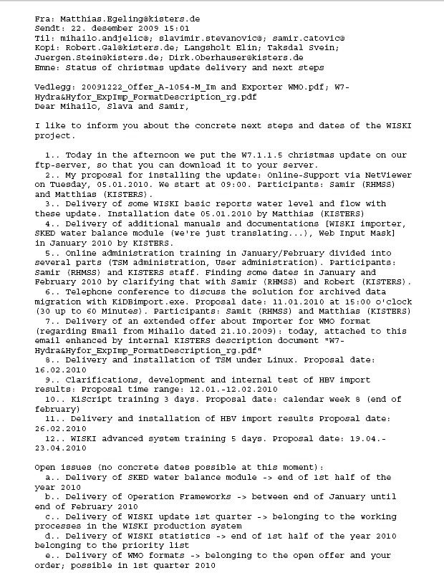

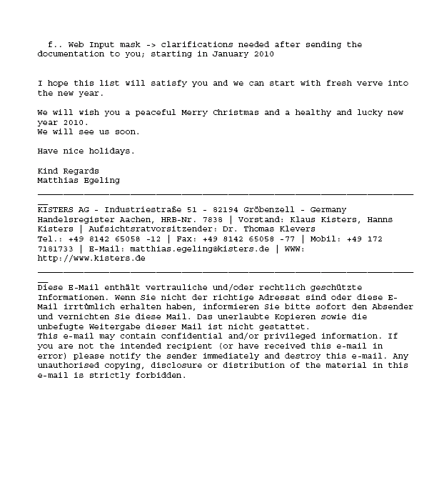

Appendix 6

Declaration of acceptance. NVE ref. 200710272-53.
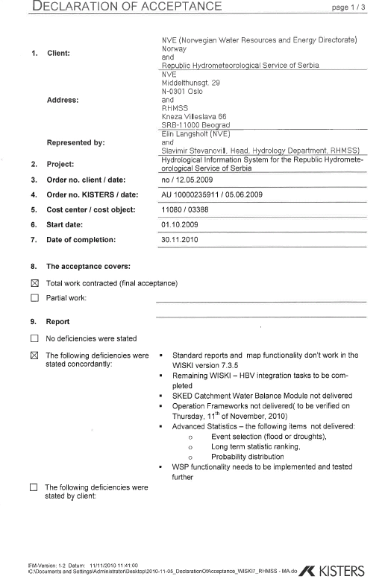

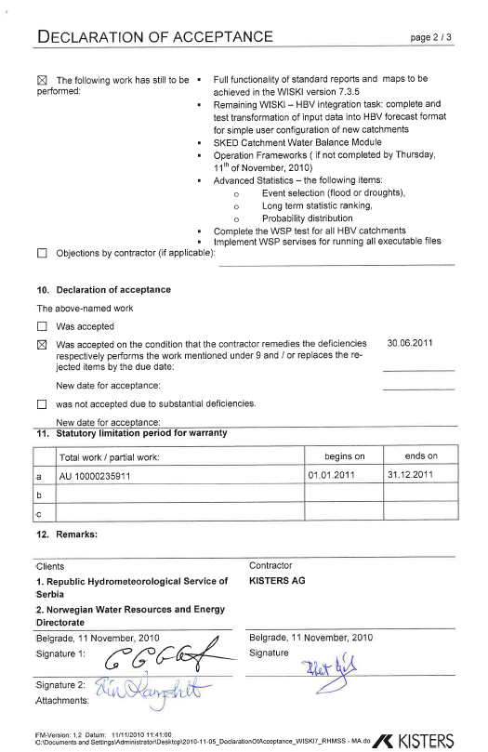

Appendix 7

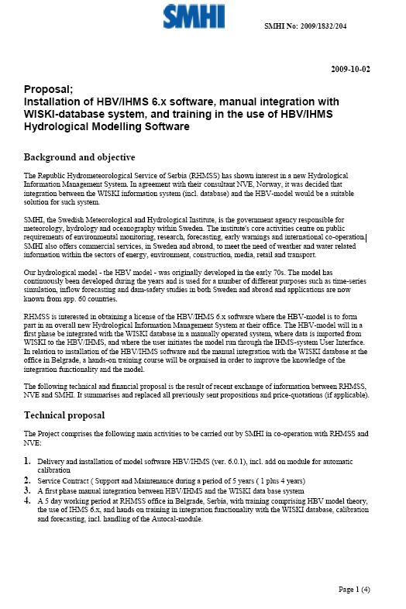
SMHI, 2010. Proposal; Installation of HBV/IHMS 6.x software, manual integration with WISKI-database system, and training in the use of HBV/IHMS Hydrological Modelling Software. NVE ref. 200710272-23.



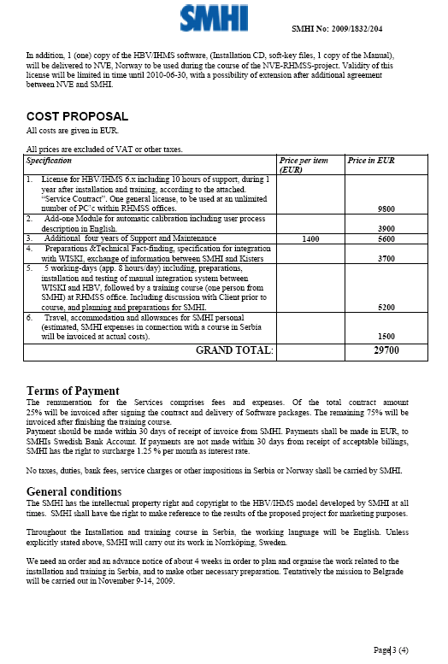

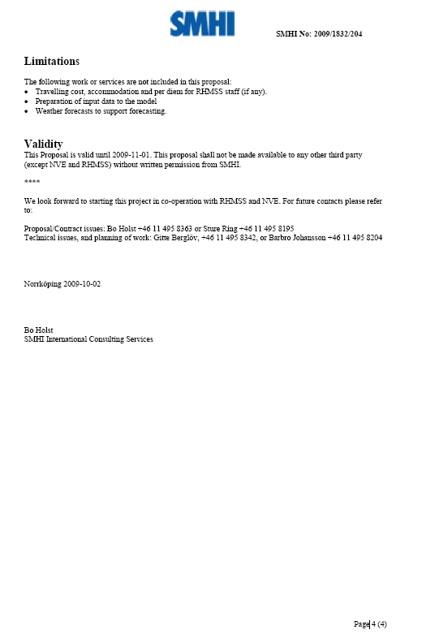

Appendix 8


NVE, 2009. Order of software, installation of software and training course. NVE ref. 200710272-24.

Appendix 9

HBV models for 10 Pilot catchments in Serbia. Calibration results. NVE ref. 200710272-63.

Appendix 10

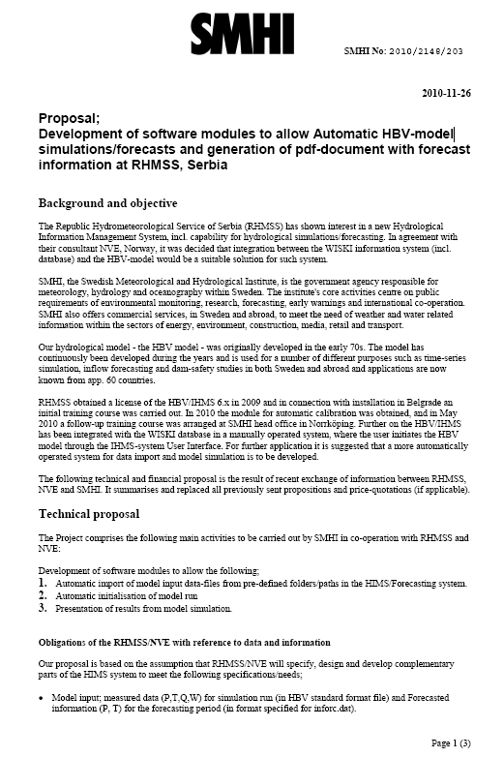
SMHI, 2010. Proposal; Development of software modules to allow Automatic HBV-model simulations/forecasts and generation of pdf-document with forecast information at RHMSS, Serbia. NVE ref. 200710272-54.

